SCR | Program(s) | History/Update with 18.07
458 | CW | When EDBC is run for CW the C-IV System will assign a role of FRI and the 'Senior Parent' role reason to a person. This will allow their income to be counted in the CW AU if all the following conditions are met;  - The person is in the home.  - The person does not have an open application (either never applied, or previously had their application closed).  - The person is not receiving SSI or SSI/SSP.  - The person has a child in common with an applicant who has an open status.  - The child in common is a minor parent to an aided child.  - The applicant parent has care and control of the minor parent's child.  Additionally, Senior Parent has been added as a Role Reason selection option to allow you to rescind or enter an application for Active FRI program persons.
467 | CF | When CF is run, it will aid an otherwise eligible student who is self-employed at least 20 hours per week/80 hours per month and receives gross weekly earning equal to the federal minimum wage multiplied by 20 hours.
933 | FC | The placement types THP+FC and THPP and their corresponding rates are available in the C-IV System. If a Non-Minor Dependent (NMD) Foster Care recipient is in a THP+FC or THPP placement and is aided on a CalFresh program, the entire Foster Care grant is excluded from the CalFresh budget. The Foster Care Placements - Add and Edit job aid has been updated for this change.
8905 | All | The following changes have been made to the Gen 2000:  - Customers may now request this form through the IVR and it posts to C4Yourself in real-time.  - The form has been reformatted to Portrait (rather than landscape view)  - A Y/N General Assistance indicator has been added to the form  In the column to the left, I have included a sample of the updated form.
10299 | All | In the C-IV System, the Case Summary page has been updated to include an indicator when Customers have linked their C4Yourself account to the C-IV System case. Screenshot samples are in the column to the left  In C4Yourself, a new page has been created under Manage My Account Profile called View My Registered Case(s). This page will display the all C-IV System case numbers linked to the C4Yourself account (active or inactive).
10668 | MC | MAGI customers who turn 65 (not a parent/caretaker relative) must be evaluated for Non-MAGI. The C-IV System now has a batch sweep that identifies MAGI Customers turning 65 years of age who are no longer eligible to MAGI MC, then generates and sends them a Non-MAGI screening packet. The packet has a due date 30 days from the date it is generated.  The Non-MAGI Screening Aged 65 Packet - Non-MAGI Screening Turning 65 Redetermination Packet is available in English and Spanish in the Template Repository. The Packet will include the following forms:  - Coversheet and Business Reply Envelope  - MC 604 IPS - Additional Income and Property Information Needed for Medi-Cal  - Non-MAGI Information Brochure  - Voter Registration Cardstock (through Central Print ONLY)  The following functionality has also been added with the SCR:  - Once the packet is generated and sent a Journal entry will be logged.  - When the packet is returned a Task will be created reminding you to review the RE packet.  - A text message will also be sent to customers who have opted into texting, let them know their packet has been sent to them.
12270 | All | A ‘Clear’ button has been added to the Contact Detail page if the customer has a recorded Voice Print. The Clear button will only be displayed if the customer has recorded a Voice Print AND your county has given you the rights to be able to clear the Voice Print. Clicking the 'Clear' button marks the Voice Print for deletion, and creates a journal entry. Once the Voice Print has been cleared, you should instruct the customer to call back into the IVR System, where they will be prompted to re-record their Voice Print if they choose.  The Job Aid - interactive Voice Response has been updated for this change.
12413 | CF | The C-IV System determines ESAP whenever EDBC is run and this determination displays on the CalFresh EDBC Summary page. The redetermination period will be;  - Set to a 36-month redetermination period if the ‘Meets ESAP Criteria’ is set to ‘Yes’ (either by the system or set by the user)  - If the ‘Meets ESAP Criteria’ is set to ‘No’, the existing RE period determination will be used to set a 12-month RE (or 5 months for TCF, or 24 months as appropriate).  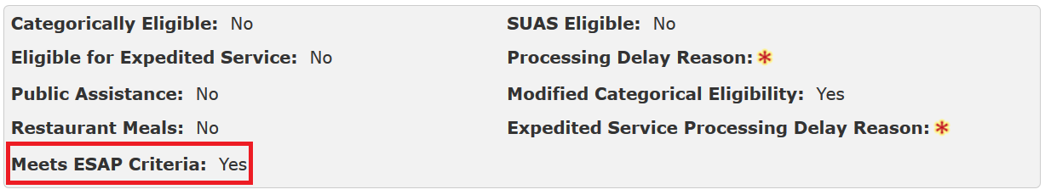  The CF 377.2D will be generated and sent, once EDBC has been run and saved.  An ESAP indicator has also been added to the CF EDBC Override pages.
100272 | MC | Effective 01/01/2018, the CSRA is $123,600.00 and the maximum spousal income allocation/minimum monthly maintenance needs allowance is $3,090.00.
100436 | All | The Prior County RE Due Month now displays on the Application Detail and New/Reapplication Detail pages for the eICT receiving county for CalFresh, CalWORKs, and Medi-Cal eICTs when received in the eICT. When the you run EDBC to approve the program, the C-IV System sets the RE due month based on the due month received from the sending county. The following job aids have been updated for these changes: Add a Person to a Case or Program, Inter-County Transfer - Manual, and Inter-County Transfers - Receiving County.

