CalSAWS | Generic User Login LMS Instructions
Purpose: The purpose of this document is to provide the Counties instructions on how to access the CalSAWS Learning Management System (LMS) by using the Generic User Accounts.

- Access the LMS:

Link: lms-ca.calsaws.net

- Type in your Generic User Account Login ID and Password

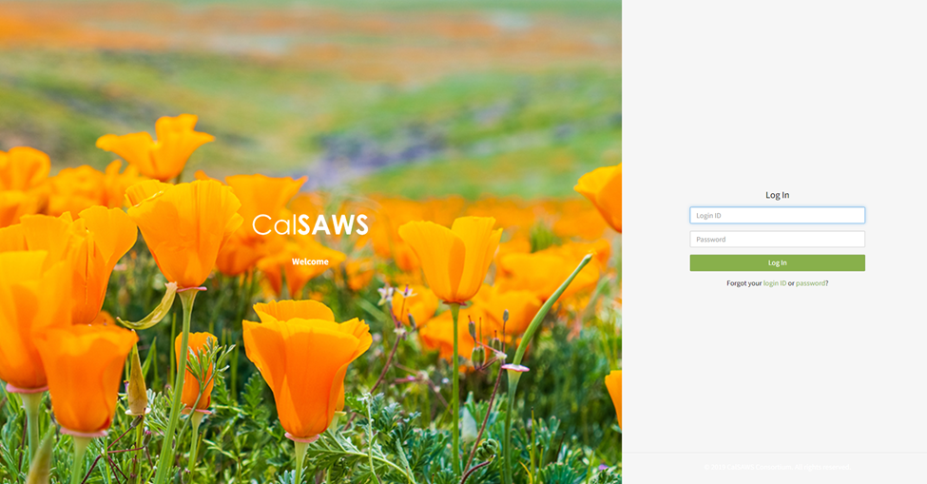

- Once you have logged in, access the Orientation Web-based Trainings (WBTs) by clicking on the “001 – Orientation” link in the right-hand side window pane.

- Begin to take your Orientation WBTs by clicking on the Course links. Please note that Orientation 02 will cover additional features of the Learning Management System.

