CALSAWS M&O BI-WEEKLY STATUS REPORT
Reporting Period: November 15, 2021 – November 28, 2021

Table of Contents
1.0 Executive Summary 4
1.1 CalSAWS Project Status Dashboard 4
1.2 Highlights from the Reporting Period 6
2.0 Project Management 7
2.1 Project Deliverables Summary 7
2.2 Highlights for the Reporting Period 7
2.3 CRFI/CIT Communications Status 8
2.4 SCIRFRA/SCERFRA/SIRFRA/SARRA Information 9
2.5 Deviation from Plan/Adjustments 10
3.0 Maintenance and Operations 11
3.1 Service Management 11
3.1.1 Overview 11
3.1.2 CalSAWS Help Desk Metrics 12
3.2 Technology Operations 16
3.2.1 CalSAWS Management and Operations 16
3.2.2 Service Level Agreement (SLA) Outcomes (Met/Missed) (CalSAWS) 17
3.3 Production Defect Backlog 18
3.3.1 Release Schedule Production Defect Fix 18
3.4 Production Operations 19
3.4.1 Release Communications 19
3.4.2 Root Cause Analysis (RCA) 20
3.4.3 Batch Operations 21
3.5 ForgeRock 21
3.6 Innovation Lab 22
3.7 Imaging 22
3.8 Customer Service Center (CSC) 23
3.9 IVR Bot Enhancement Pilot for San Bernardino County 23
3.10 Deviation from Plan/Adjustments 23
4.0 Application Development 24
4.1 Priority Release Summary 24
4.2 Application Development Status 26
4.3 Release Management 26
4.3.1 Release Test Summary 26
4.3.2 Automated Regression Test (ART) Coverage 28
4.4 Training Materials Update 29
4.5 Deviation from Plan/Adjustments 30
5.0 Regional Updates 31
6.0 Appendices 37

Executive Summary

CalSAWS Project Status Dashboard
Table 1.1-1 – Status Dashboard

Topic | CalSAWS System | Highlights
Availability |  | - The CalSAWS System did not experience any unplanned outages
Defects |  | - There are 217 active Production defects
Incidents |  | CALSAWS BROADCAST: Starting at 4:22 p.m. on November 15, 2021, users experienced connectivity issues with FIS (EBT Vendor) causing EBT transactions to timeout and fail. Users were unable to print EBT cards or perform EBT related transactions. This issue was resolved by the FIS team as of 5:22 p.m. on November 15, 2021. Note: Both CalSAWS and CalWIN Counties are impacted by this issue.  - CALSAWS BROADCAST: Starting at 2:00 p.m. on November 17, 2021, login and API issues were detected for the CalSAWS Imaging System. Users were unable to access the Imaging System or experienced performance degradation. This affected BenefitsCal and the CalSAWS batch process. Documents sent through these processes were queued and delivered to imaging once the issue was resolved. The issue was resolved as of 2:35 p.m. on November 17, 2021. The Imaging Vendor identified the root of the performance degradation and applied the resolution, resuming normal performance.  - CALSAWS BROADCAST: Starting at 8:00 a.m. on November 17, 2021, the daily MEDS Alert file was unable to be processed in CalSAWS. Daily MEDS Alerts were not available in CalSAWS, and Los Angeles County workers did not have tasks created to process MEDS alerts. Workers were able to login into the MEDS terminal for information. As of 12:30 p.m. on November 24, 2021, the issue has been resolved and the MEDS alerts have been processed  - CALSAWS BROADCAST: Starting at 4:03 p.m. on November 22, 2021, the CalHEERS response for eligibility determination was delayed. Eligibility determination response from CalHEERS was not received in CalSAWS. At 9:00 p.m. on November 22, 2021, the Project team confirmed that the connectivity between CalHEERS and CalSAWS was restored. CalHEERS enabled the queued-up transactions to be sent to CalSAWS for processing at 4:00 a.m. on November 23, 2021, after the completion of the MEDS monthly renewal activity. The Project team continues to monitor the CalHEERS – CalSAWS connectivity  - CALSAWS BROADCAST: As of 6:00 a.m. on November 17, 2021, the Semi-Annual Reporting (SAR) Dashboards were not refreshed with the latest data from November 16, 2021. As of 6:00 a.m. this morning, the Semi-Annual Reporting (SAR) Dashboards are refreshed with the latest data including the data from November 16, 2021  - CALSAWS BROADCAST: As of 6:00 a.m. on November 2, 2021, the ‘TEMP 2220 – Children Aged 5-17 in Families Receiving CalWORKs’ report was not generated. As of 6:00 a.m. this morning, the ‘TEMP 2220 – Children Aged 5-17 in Families Receiving CalWORKs’ report has been generated and is available for users  - CALSAWS BROADCAST: Starting at 08:00 p.m. on November 18, 2021, incoming calls and courtesy callback calls in the Amazon Connect Contact Center are intermittently failing to connect, or customers are unable to hear the agent. Calls that fail to connect are automatically routed to a different agent. If the customer is unable to hear the agent, please have the agent transfer the call back to the queue. The Project team is actively gathering logs and working directly with AWS to analyze the issue. Impacted Counties: San Bernardino, Riverside, Kern, Kings, Stanislaus, Marin, Humboldt, Butte, Yuba, Sutter, Monterey, San Joaquin, Merced, and Shasta  - CALSAWS BROADCAST: Starting at 8:00 p.m. on November 18, 2021, the Custom Call Control Panel (CCP) is displaying the message “Error Retrieving Table Data” after being logged in for an hour. Workers may not be able to see the latest information on CCP after being logged in for an hour. The Project team is actively investigating the issue. Defect CA-237102 has been created to address the issue. An update will be provided when the issue is resolved. Impacted Counties: San Bernardino, Riverside, Kern, Kings, Stanislaus, Marin, Humboldt, Butte, Yuba, Sutter, Monterey, San Joaquin, Merced, and Shasta  - CALSAWS BROADCAST: Starting at 6:00 a.m. on October 1, 2021, NHR (New Hire Registry) abstracts for the September 2021 and the October 2021 months are processed in CalSAWS and are available for workers to view. However, some of the abstracts are not yet assigned to any worker. The Project team is actively investigating the issue. Defect CA-237189 has been created to address the issue  - CALSAWS BROADCAST: Starting at 2:30 p.m. on November 23, 2021, some users were experiencing slowness or errors while navigating or performing transactions in CalSAWS. The Project team is actively working to resolve the issue
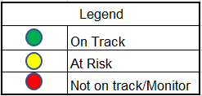

Highlights from the Reporting Period

- The CalSAWS Team successfully deployed CalSAWS Major Release 21.11 to CalSAWS Production
- The CalSAWS team successfully deployed CalSAWS minor releases 21.11.15, 21.11.17, 21.11.18, 21.11.23, and 21.11.27 to CalSAWS production

- Planned Outages:
  - Scheduled CalSAWS Outages:
    - CalSAWS Production Outage – on November 21, 2021 from 6:00 a.m. until 3:00 p.m. During this period, users were unable to access the CalSAWS application. Users were redirected to a “Read Only” version of the CalSAWS application.
  - Scheduled External System Outage:
    - CalSAWS Imaging Solution (Hyland) Outage – on November 19, 2021, at 10:00 p.m. until 1:30 a.m. on Saturday, November 20, 2021. During this period, CalSAWS Imaging services were down. Users were unable to access the imaging system. CalSAWS Batch and BenefitsCal were also unable to access Imaging services. There was no impact to Los Angeles County
    - Your Benefits Now (YBN) and BenefitsCal in Offline Mode – on November 21, 2021, from 6:00 a.m. until 3:00 p.m. During this period, Your Benefits Now (YBN) and BenefitsCal was placed in Offline Mode. Transactions were queued and processed upon completion of maintenance activities. EBT balance and case information was not available to view from YBN or from BenefitsCal

Project Management

Project Deliverables Summary
Table 2.1-1 – Overall Summary of Deliverable Status for Current Reporting Period

Del # | Deliverable Name | Team | Status ^{[1]} | Status
 | None for the reporting period
[1] Status: Green: On schedule, performing as planned; Amber: Potential delay/monitor with no material schedule impact; Red: Behind schedule and requires escalation

Highlights for the Reporting Period
- Continued Project administration, facility management, office management support, and financial management tasks
- Continued supporting the SOC 1 audit for the State Fiscal Year 2020/21 review period
- Continued performing contract management activities:
  - Received the approval from the CalSAWS JPA Board of Directors for contact Change Notice No. 12 on November 19, 2021. Change Notice No. 12 included the following:
    - Use of funds from the base agreement’s Regulatory & Administrative Change Budget Services allocation for CalHEERS Maintenance and an extension of Post-Deployment Support for the C-IV Counties
    - Administrative updates to shift a number of Modifications and Enhancements hours from Schedule 1 (Statement of Work for CalSAWS M&O Project) of Exhibit X to Schedule C (Application Software Modifications and/or Enhancements) of Schedule 3 to Exhibit X
  - Continued development of contract Change Notice No. 13 which is planned to be submitted to the CalSAWS JPA Board of Directors for approval on December 17, 2021 and is planned to include the following:
    - Use of the contract’s R&A Change Budget Services allocation for CDSS reports support and enhancements related to threshold languages for correspondences
    - Technical updates to Exhibit U, the Statement of Work for the CalSAWS DD&I Project, to reflect the final approved deployment schedule for Non-State Forms
    - Technical updates to Exhibit AC, the Statement of Work for the CalSAWS Customer Service Center Project, to reflect the current approved schedule for design activities
  - Tracking of County Purchases:
    - Reference Appendix B for detailed tracking of County Purchases

CRFI/CIT Communications Status

- The following table outlines CalSAWS Information Transmittals (CITs) for the reporting period ending November 28, 2021

Table 2.3-1 – CITs

CIT ID | Subject | Category | Distribution Date | Primary  CalSAWS Contact | Backup  CalSAWS Contact
0341-21 | CA-233939 CalFresh Emergency Allotments for October 2021 List Posted | Informational | November 16, 2021 | Caroline Bui | Binh Tran
0342-21 | CalSAWS Imaging – Best Practices for OCR Success | Informational | November 16, 2021 | Rhiannon Chin | Chris Vazquez
0344-21 | FFPSA | Informational | November 19, 2021 | Ignacio Lázaro | Laura Ould
0346-21 | CA-208191 Changes to the Authorized Representative pages - Revised Job Aid and List | Informational | November 22, 2021 | Maggie Orozco-Vega | Nina Butler
0347-21 | Completion of the Citizenship Detail page for COFA individuals receiving both MC and CAPI | Informational | November 23, 2021 | Elisa Miller | Maureen Votta
0348-21 | CalSAWS Imaging Index Values Reference Guide & Form Name Matrix | Informational | November 24, 2021 | Rhiannon Chin | Erick Arreola

- The following table outlines CalSAWS Requests for Information (CRFIs) for the reporting period ending November 28, 2021

Table 2.3-2 – CRFIs

CRFI ID | Subject | Distribution Date | Status | Response Due Date | CalSAWS Contact
21-066 | Updating CalSAWS County Fiscal Contact Information | November 17, 2021 | Open | December 8, 2021 | Chia Thao
21-067 | NA 791 Post Adoptions Services (PAS) Phone Number | November 22, 2021 | Open | December 3, 2021 | Ignacio Lázaro
21-068 | 1099 Interface Schedule Option | November 23, 2021 | Open | December 13, 2021 | Sheryl Eppler

Table 2.3-3 – Overdue CRFIs

- The following table outlines overdue CalSAWS Requests for Information (CRFIs) for the reporting period ending November 28, 2021

CRFI ID | Subject | Region 1 | Region 2 | Region 3 | Region 4 | Region 5 | Region 6
None

SCIRFRA/SCERFRA/SIRFRA/SARRA Information

- The following tables outline current CalSAWS SAWS Communication Information Request for Research and Analysis (SCIRFRA), SAWS Cost Estimation Request for Research and Analysis (SCERFRA), SAWS Information Request for Research and Analysis (SIRFRA), and SAWS Advocates Request for Research and Analysis (SARRA)

Table 2.4-1 – Summary of SCIRFRA/SCERFRA/SIRFRA/SARRA Requests
Status | Total
New | 1
Rejected | 1
Assigned | 5
Completed | 551
Duplicate | 17
Withdrawn | 20
Pending Clarification | 1
Total | 596

Note: SCIRFRA/SCERFRA/SIRFRA/SARRA requests from November 2018 through the end of the reporting period

Table 2.4-2 – Details of SCIRFRA/SCERFRA/SIRFRA/SARRA Data Received
ID | Description | Status | Due Date | Response Received Date | Notes
CWDA | CWDA – Eliminate MC Premiums for Kids and Pregnant People | Completed | November 9, 2021 | November 17, 2021
SIRFRA 3694 | 3694 – CalFresh Confirm Data Pull – November 2021 | Completed | November 15, 2021 | November 16, 2021
SIRFRA 3697 | 3697 – PACF Breakout Request – October 2021 | Completed | November 16, 2021 | November 17, 2021
SIRFRA 3698 | 3698 – CalOAR Availability of 19C, 19D, and 19E Files | Completed | November 17, 2021 | November 17, 2021
21-545 | 21-545 – STAT 47 and Consortia Changes for FNS Final Rule Compliance | Completed | November 18, 2021 | November 18, 2021
21-546 | 21-546 MEDS Modifications | Pending Clarification | November 18, 2021 | No response
SIRFRA 3685 | 3685 -Stage One Child Care Home Provider Data | Completed | November 19, 2021 | November 19, 2021
SIRFRA 3701 | 3701 – 18 Month Interim Report for Combined Reminder Notice | Completed | November 19, 2021 | November 19, 2021
SIRFRA 3700 | 3700 – CalFresh Churn Report (CF 18) | Completed | November 24, 2021 | November 22, 2021
SIRFRA 3703 | 3703 – Adoption of Mini Budget on Approval, Denial, Discontinuance NOA’s | Completed | November 26, 2021 | November 12, 2021
SIRFRA 3696 | 3696 – CalWORKs Application, Redetermination, and Closed Cases | Assigned | December 2, 2021 | No response
SIRFRA 1161 | 1161 – RMR Data Questions | Assigned | December 3, 2021 | No response
SCERFRA 21-547 | 21-547 – Redetermination Reminder NOA | Assigned | December 3, 2021 | No response
SIRFRA 3704 | 3704 – CalFresh SSI Queries 1 & 2 | Assigned | December 10, 2021 | No response
SIRFRA 3699 | 3699 – Stage One Child Care Home Provider Data | Assigned | December 20, 2021 | No response
SIRFRA 3705 | 3705 – Voluntary Contribution | New | December 22, 2021 | No response

Deviation from Plan/Adjustments
- None for the reporting period

Maintenance and Operations

Service Management

Overview

- Configuration Management Database (CMDB) project development of Proof of Concept (POC) continues to determine the discovery footprint. The mid-tier polling agent has been established in Amazon Web Services (AWS) development and data has been established in the system. Setup for the Onprem data collection is underway
- Consortium Security team has a request for Change Process Hardening for the Technical Change Management. Development is on hold awaiting requirements associated to fielding
- Innovation hub’s application status page has been moved into the development environment and is ready for internal process evaluation. Building out data collection processes for automated status selection. Awaiting connection to LAMBDA function
- Completed - Cherwell bi-directional integration has been completed and validated. A minor defect has been confirmed and is ready for CAB review the 8th
- The Data Source requested second phase will be the creation of workflows for each of the requests to automatically handle distribution to teams. Working with the teams on requirements associated to workflows
- ForgeRock and ServiceNow integration discussions of requirements underway

Figure 3.1-1 ServiceNow Timeline
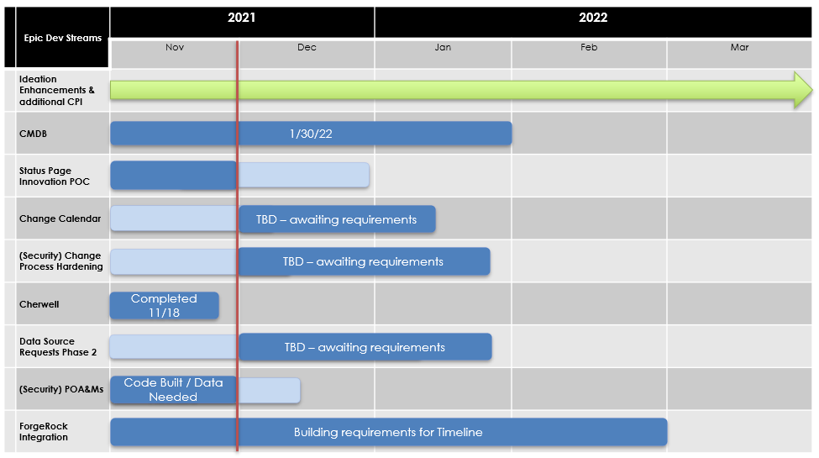

CalSAWS Help Desk Metrics

Figures 3.1.2-1 and 3.1.2-2 – CalSAWS ServiceNow Cases per Week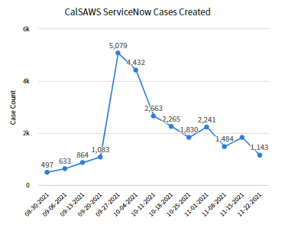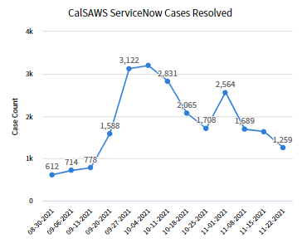

Note: The graphs represent the ServiceNow cases associated to all 40 Counties. Cases represent the
first level of ticketing that enters the ServiceNow system. The dates in x-axis represent the start of week

Figures 3.1.2-3 and 3.1.2-4 – CalSAWS ServiceNow Incidents

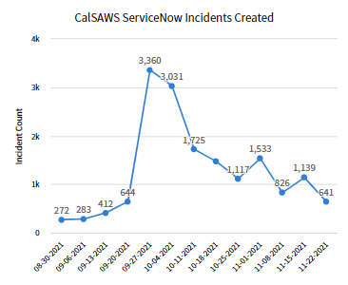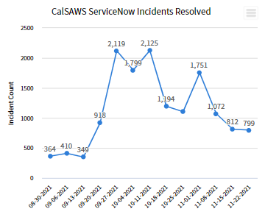

Note: The graphs represent the ServiceNow Incidents associated to all 40 Counties. Incidents are escalations derived from case attempts to triage the issue. The dates in x-axis represent the start of a week.

Figures 3.1.2-5 and 3.1.2-6 – CalSAWS ServiceNow Problems

Note: The graphs represent the ServiceNow problems associated to 40 Counties. Problems represent issues that can have a many to one relationship with incidents and the final step in escalation. The dates in x-axis represent the start of a week.

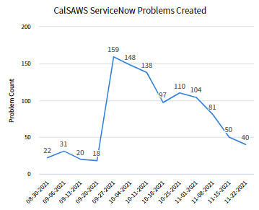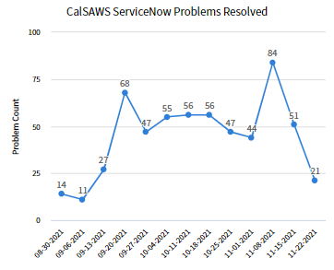

Figure 3.1.2-7 – CalSAWS ServiceNow Incidents by State and Age

Note: In the pivot table below, the (empty) aging category represents tickets less than a day old.

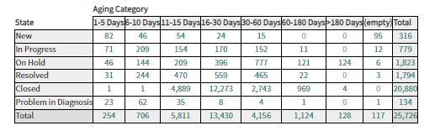

Figure 3.1.2-8 – CalSAWS ServiceNow Incidents by Resolution Code

Note: The pie chart below represents Incidents resolved within the past 2 months.
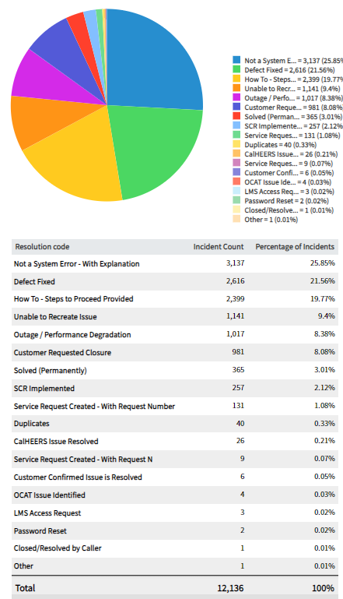
Figure 3.1.2-9 – CalSAWS ServiceNow Incidents Created by Category
Note: The pie chart below represents Incidents by Category created within the past 2 months.
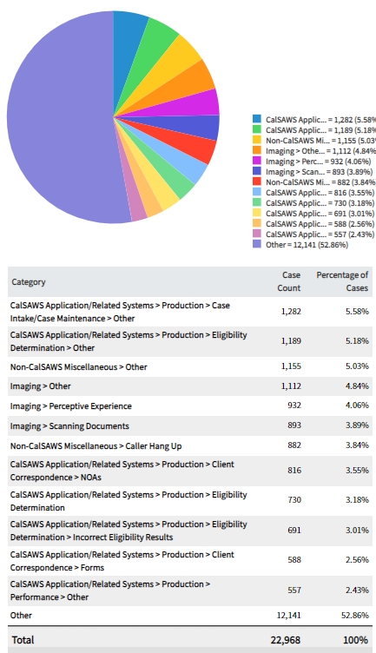

Figures 3.1.2-10 – CalSAWS ServiceNow Cases Created for Remote Maintenance

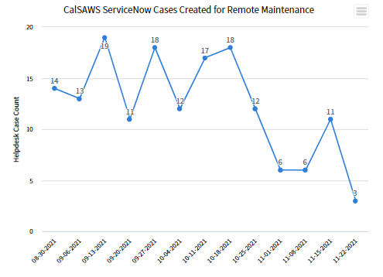

Technology Operations
The CalSAWS Technology team provides technical infrastructure support for the deployment of system changes and system maintenance activities in accordance with the CalSAWS Change Control Process. Technical infrastructure support activities include configuration and setup of development and non-Production environments for work items, infrastructure (middleware and database)/architecture changes, promotion of application builds through the development stages, and deployment of application builds into the CalSAWS Production environments

CalSAWS Management and Operations

- Switch Automation
  - Switch Refresh completed for 71% of sites, with 71% of total devices completed across the sites (415 of 582 switches)
  - Refresh planned for Merced Counties during month of December
  - Onboarded additional resources to expedite switch refresh
- Remote Connectivity
  - ZScaler Design in Progress
  - Migrated County staff to new Equinix Virtual Private Network (VPN) on November 20, 2021
- C-IV Data Center Decommissioning
  - SV1 Data Center build and server connectivity in progress
  - LA3 Design and build to start next week
  - Production Data Center decommission
    - Starting preparation work on December 7, 2021
    - Physical decommission and shredding to start week of December 13, 2021
    - Target completion is December 16, 2021

Table 3.2.1-1 – CalSAWS Upcoming Maintenance
Scheduled Date | Activity Description
December 3 - 5, 2021 | October 2021 Database Patching on System Test and Performance Test
December 5, 2021 | Production Database Amazon Web Service (AWS) Linux Operating System (OS) Patches November 1, 2021, Patch Baseline (CalSAWS Outage needed from 4:00 p.m. – 8:00 p.m.)
December 9, 2021 | Sandbox Linux Operating System (OS) Patching December 1, 2021, Patch Baseline
December 12, 2021 | Development Linux Operating System (OS) Patching December 1, 2021, Patch Baseline
December 17, 2021 | ForgeRock Production Release 21.12.17 (Planned Change)
December 19, 2021 | October 2021 Database Patching on Production Databases
December 19, 2021 | Production Linux Operating System (OS) Patching December 1, 2021, Patch Baseline (Planned Change)
December 24 - 26, 2021 | October 2021 Database Patching on PRT (Policy, Review, Training), County Preview, Training and Sandbox Databases
January 2, 2022 | Production Database Amazon Web Service (AWS) Linux Operating System (OS) Patches December 1, 2021, Patch Baseline (CalSAWS Outage needed from 4:00 p.m. – 8:00 p.m.) (Planned Change)

Table 3.2.1-2 – CalSAWS Incident Follow-up Summary

Ticket ID | Description | Impact Date / Time | Impact | Resolution
None

Service Level Agreement (SLA) Outcomes (Met/Missed) (CalSAWS)

- The CalSAWS System met all Service Level Agreements (SLAs) within the reporting period

Production Defect Backlog
The Production defect backlog bar-chart depicts the balance of open (unresolved Production defects) and closed defects, week-over-week. Defects are closed upon system test validation and release deployment to Production

Figure 3.3-1 – Production Defects Backlog Weekly Trend
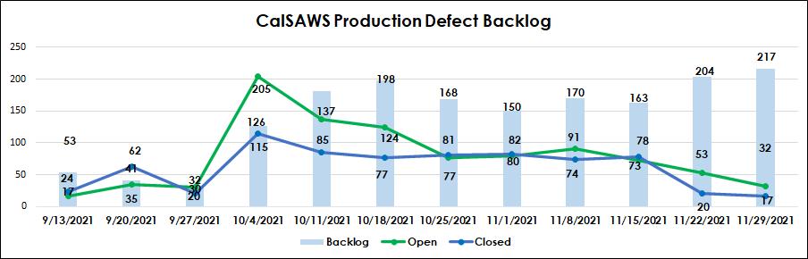

Release Schedule Production Defect Fix

The Production Defect fix – Release Schedule reflects the number of defects planned in alignment to each monthly release (20.01, 20.02, etc.). The status of the defect in the fix and re-test pipeline is also reflected for each of the defect severity categories to establish the number of defects remaining to be fixed, re-tested, and closed for each of the releases

Table 3.3.1-1 – Production Defect Fix – Release Schedule

CalSAWS Production Defect Count by Release
Count of Defects | Release
Severity | 21.07 | 21.11 | 22.01 | 22.02 | 22.03 | TBD | Grand Total
2-Normal/Medium | 86 | 4 | 10 |  |  | 2 | 102
New |  | 1 | 2 |  |  |  | 3
In Progress | 1 | 1 | 6 |  |  | 1 | 9
Closed | 85 | 2 | 2 |  |  | 1 | 90
3-Normal/Low | 512 | 67 | 164 | 1 |  | 10 | 754
New |  | 6 | 61 |  |  | 4 | 71
In Progress |  | 15 | 102 | 1 |  | 5 | 123
Closed | 512 | 46 | 1 |  |  | 1 | 560
4-Cosmetic | 20 | 3 | 7 |  | 1 |  | 31
New |  |  | 1 |  | 1 |  | 2
In Progress |  | 1 | 6 |  |  |  | 7
Closed | 20 | 2 |  |  |  |  | 22
Grand Total | 618 | 74 | 181 | 1 | 1 | 12 | 887

Note: Data Change Requests (DCRs) have been excluded from the above reporting because they follow a separate deployment process

Production Operations

Release Communications
- CalSAWS Release 21.11 Communications:
  - See table 3.4.1-1 for details
- CalSAWS Release 22.01 Communications:
  - See table 3.4.1-2 for details

Table 3.4.1-1 – CalSAWS Release 21.11 Communication Activities

TASK | DATE(S) | OWNER
Sent Release 22.01 Major Upcoming Changes documentation | October 22, 2021 | Training
Sent draft Release Notes file to Regional Managers and Consortium staff for review | November 15, 2021 | Production Operations
Send summary of changes in CalSAWS Release 22.01 in CalSAWS Health Report | November 22, 2021 –November 26, 2021 | Production Operations
Webcast on CalSAWS Release 22.01 | November 23, 2021 | Production Operations/ Consortium Policy and Design
22.01 CalSAWS Application Development and Training Release Notes Broadcast | November 24, 2021 | Production Operations
CalSAWS Release 22.01 Greenlight Meeting | November 25, 2021 | Release Management/QA
CalSAWS 22.01 Post-Release Checkpoint Call | November 22, 2021 –November 24, 2021 | Production Operations

Table 3.4.1-2 – CalSAWS Release 22.01 Communication Activities
TASK | DATE(S) | OWNER
Send Release 22.01 Major Upcoming Changes documentation | TBD | Training
Send draft Release Notes file to Regional Managers and Consortium Staff for review | January 10, 2022 | Production Operations
Send summary of changes in CalSAWS Release 22.01 in CalSAWS Health Report | January 17, 2022 – January 21, 2022 | Production Operations
Webcast on CalSAWS Release 22.01 | TBD | Production Operations/ Consortium Policy and Design
22.01 CalSAWS Application Development and Training Release Notes Broadcast | January 18, 2022 | Production Operations
CalSAWS Release 22.01 Greenlight Meeting | January 19, 2022 | Release Management/QA
CalSAWS 22.01 Post-Release Checkpoint Call | January 24, 2022 – January 26, 2022 | Production Operations

Root Cause Analysis (RCA)
- General Relief Dashboard Missing Data:
  - Issue: The General Relief Dashboard was missing data for the past 5 months after the implementation of defect CA-234680. On November 2, 2021, UI optimizations were implemented to speed up the load of the General Relief Dashboards. Upon implementation, the wrong QVD (QlikView Data) was selected which had not been updated for 5 months. This caused the dashboard on November 3, 2021, to not display any data for the past 5 months.

- Batch Completion Delayed November 2, 2021:
  - Issue: Around 2:00 a.m. on November 3, 2021, Batch Ops team observed slowness in the execution of Super Trigger jobs. As a normal routine, Database Administration and Batch & Interface teams were involved in trouble shooting of the long running Super Trigger jobs. Database Administration team identified that the delay in execution was due to contention between multiple threads. Later it was identified that the issue was tied to a DCR execution by Conversion team for Legacy Data Systems (LDS). The issue was fixed, and Super Trigger jobs could complete by early morning on November 3, 2021. LDS DCR also caused EBT Demographic files job to be failed. Subsequent DCR was applied in the evening which resolved the issue and allowed the EBT demographic files to complete successfully

Batch Operations
- Supported nightly batch operations and coordinated with various AppDev/DBA/Tech teams to resolve issues/failures during the batch window
- Supported cyclic/high frequency/Event streaming jobs and resolved issues/failures
- Addressed questions/concerns raised by counties through the emails and processed warrant/positive pay and other backlog files
- Implemented and Validated 21.11 release BSCRs
- Coordinated with Application Development/DBA/Tech team and testing batch performance for Oracle 19C
- Processed Holiday/ Thanksgiving backlog files
- Continued working on operations System Change Requests (SCRs) # Holiday calendar, Meds Recon, and 10-day cutoff
- Conducted KT session for offshore team on monitoring nightly batch operations

ForgeRock
- Enabled capability for Delegated Administrators to view and edit Community Based Organizations (CBO) users across all counties
- Drafted Multifactor Authentication Instructions for Logging into CalSAWS Applications County Informational Transmittal (CIT); submitted to CIT Review Committee for feedback
- Distributed Delegated Administrators are Now Able View and Edit All CBO User Accounts Across All Counties County Informational Transmittal (CIT)
- Continued development work on enabling RADIUS Multifactor Authentication (MFA) authentication in Access Manager
- Attended Los Angeles County Federated Authentication Greenlight Meeting- tentative production deployment of December 17, 2021, CIT will be distributed closer to December 17, 2021 go-live
- Continued development work on onboarding existing applications outlined in Statement of Work (SOW)
- Secured Consortium Advisory Board (CAB) approval for ForgeRock 21.12.03 Production Release
- Met with Multifactor Authentication (MFA)/ Privileged Access Management (PAM) Oversight Committee to address County feedback on MFA Roll Out strategy

Table 3.5-1 – ForgeRock Milestones

MILESTONES | Prod Deployment DATE | STATUS
ForgeRock 21.11 Production Deployment | 21.12.03 | Cancelled
Enable Lifecycle Management for ServiceNow Accounts | 21.12.17 | In progress
Apply Multi-Lingual Knowledge Based Authentication (KBA) Patch for BenefitsCal defect | 21.12.17 | In progress
ForgeRock Application Onboarding: Consortium AWS Production clients | 21.12.17 | In progress
ForgeRock LA County Federated Authentication | 21.12.17 | In progress
Enable ForgeRock Multifactor Authentication (MFA) capabilities for Project Users | 21.12.17 | In progress
ForgeRock Application Onboarding: Adobe Experiences Production clients | TBD | Completed
ForgeRock Application Onboarding: ZScaler Production clients | TBD | In progress

Innovation Lab
- Continued Innovation Lab activities
  - Batch Performance Initiatives (Discovery Phase)
    - Scored initiatives with Innovation Workgroup for prioritization
  - Streamlined CalSAWS Lobby Application (Describe Phase)
    - Continued requirements for lobby application enhancements
  - System Status for End Users (Co-Create Phase)
    - Continued prototype project management timeline and activities
  - CalSAWS Production Calendar (Discovery Phrase)
    - Continued prototype project management timeline and activities
  - Cybersecurity Awareness Program (Discovery Phase)
    - Set up discussion with Security team and Initiative leads to discuss business case and potential approach for a cybersecurity and phishing awareness program

Imaging
- Continued to compress large files that add to rendering times (Hyland)
- Attended CalSAWS Post-Deployment County Stakeholder calls
- Deployed Defect Fix (November 18, 2021) CA-236867 - External Agency - Document with a barcode and a blank origin are being sent to Barcode Verification instead of Task Generation
- Deployed Defect Fix (November 18, 2021) CA-235037 - External Agency Defect: Using "Equals To" in "Created by" search field causes browser to lock up
- Deployed Defect Fix (November 22, 2021) CA-234114 - External Agency Defect: Empty Batches/Folders are not Purging Nightly
- Deployed Defect Fix (November 22, 2021) CA-234651 - External Agency Defect: Page duplication in Imaging System
- Deployed SCR (November 24, 2021) CA-234911 - Update Imaging Workflows to support Case Number Searching – The retro-active update of workflow items pre-existing to this release is continuing to be updated.
- Continued to work with Counties and project on improving County exception queues

Customer Service Center (CSC)
- Continued designs for the following:
  - SCR CA-234540 – Update Call Control Panel (CCP) Security and Database connection
    - This will ensure agents are able to still login to the Call Control Panel (CCP) and handle calls if there are database issues and implement seamless failover to the standby database if needed. Still in progress
- Deployed the following:
  - SCR CA-234575 - Automate Max Queue Depth, and Predictive Handling Report
    - This will automate reports that are currently being run manually. On target to be released November 18, 2021
- Working with Security team to identify and resolve any issues found from static code scans

IVR Bot Enhancement Pilot for San Bernardino County
- Welcome Bot
  - Welcome Bot continues to successfully route approximately 80% of callers that interact with the bot
  - Push Notification is successfully deflecting approximately 13% of callers from needing to speak to a worker
  - Welcome Bot and Push Notification combined successfully deflect approximately one- third of all callers
  - SCR CA-235268 was deployed on November 23, 2021 to improve the LEX bots recognition of commonly misunderstood phrases
- Authentication Bot
  - Authentication rate remains high. Bot is authenticating on average 89% of callers that interact with the bot
- Preparing business impact analysis of Bots for upcoming executive and JPA briefings
- Moving beyond production pilot, taking inventory of future enhancements, upgrades, and customer requests for both Bots. Upcoming meeting with San Bernardino to prioritize, plan, and enable this effort

Deviation from Plan/Adjustments
- None for the reporting period

Application Development

Priority Release Summary

This section outlines the scope of defect fixes included in each Ad-Hoc priority release deployed in this reporting period.

- The CalSAWS System had Nine priority releases:
  - The CalSAWS 21.11.13 Minor Release was successfully deployed on November 13, 2021
    - One System Change Request (SCR) was deployed in the area of Fiscal
  - The CalSAWS 21.11.14 Minor Release was successfully deployed on November 14, 2021
    - Three defects were deployed in the areas of Fiscal and Online
    - Three System Change Requests (SCRs) were deployed in the areas of Batch/Interfaces and Client Correspondence.
  - The CalSAWS 21.11.15 Minor Release was successfully deployed on November 15, 2021
    - Two defects were deployed in the areas of Batch Operations, Batch/Interfaces
    - Two System Change Requests (SCRs) were deployed in the areas of Database Administration (DBA) and Technical Operations teams
  - The CalSAWS 21.11.17 Minor Release was successfully deployed on November 17, 2021
    - Two defects were deployed in the areas of Contact Center and Reports teams
  - The CalSAWS 21.11.18 Minor Release was successfully deployed on November 18, 2021
    - Sixteen defects were deployed in the areas of Batch/Interfaces, CalHEERs, Conversion, Fiscal, Imaging, Online and Reports and teams
    - Six System Change Requests (SCRs) were deployed in the areas of Automated test, Batch/Interfaces, Contact Center, Fiscal, Imaging and Online teams
  - The CalSAWS 21.11.19 Minor Release was successfully deployed on November 19, 2021
    - Two defects were deployed in the areas of the Fiscal and Reports teams
    - Five System Change Requests (SCRs) were deployed in the areas of Performance, Technical ForgeRock and Training teams
  - The CalSAWS 21.11.23 Minor Release was successfully deployed on November 23, 2021
    - Seventeen defects were deployed in the areas of Batch Operations, Batch/Interfaces, CalHEERs, Client Correspondence, Conversion, Eligibility, Fiscal, Imaging, Online, and Reports teams
    - Four System Change Request (SCRs) were deployed in the areas of Contact Center, Fiscal and Online
  - The CalSAWS 21.11.24 Minor Release was successfully deployed on November 24, 2021
    - Three defects were deployed in the areas of Batch Operations, Fiscal, Online
    - One System Change Requests (SCR) was deployed in the areas of Imaging team
  - The CalSAWS 21.11.27 Minor Release was successfully deployed on November 27, 2021
    - One defect was deployed in the areas of Client Correspondence team.

Table 4.1-1 – CalSAWS Upcoming Release
Release | Summary
21.11.30 | - Migrate Batch Job PI00M302
21.12.01 | - Add new Task Type for Outbound IVR Cancelation of Appointments
21.12.02 | - Update Application Transfer API to include BC App Submission Date  - Implement CalSAWS Case Data Removal Functionality Sprint 2  - BenefitsCal - Add CMSP Information to Application Transfer
21.12.03 | - ForgeRock: Application Onboarding - CalSAWS Jira  - ForgeRock: Application Onboarding - APEX  - Splunk Cloud ingestion of County site servers and network equipment logs  - CalSAWS batch job client creation  - Child Care-REGIONAL MARKET RATE (RMR) CEILING AND DIRECT SERVICE CONTRACT REIMBURSEMENT CHANGES  - Enable VPN CIDR Blocks for All ForgeRock Security Groups  - ForgeRock: Enable Lifecycle Management for ServiceNow Accounts  - Deploy Standalone IG  - ForgeRock: Enable RADIUS Multi Factor Authentication (MFA) in Access Manager  - ForgeRock: Los Angeles County Federated Authentication  - Add Metric Gathering in User Journeys  - Enable ForgeRock for AnyConnect VPN  - Jenkins Pipeline: Single Instance Rebuild  - Los Angeles County Prod SAML Client  - Complete Cross Region Enhancements  - Add Contact Center OAuth Clients
21.12.04 | - 2022 Social Security Title II and Title XVI Cost of Living Adjustments (SSA COLA)  - Issue November 2021 Disaster Supplement in accordance to HR 6201 Emergency Allotments
21.12.08 | - Update Duplicate Aid Logic for In-Process eICTs  - Update missing ICT Inbound Doc Type  - Update the 'Gets Duplicate Aid' check for Medi-Cal
21.12.09 | - ACIN I-XX-21 2022 CAPI COLA
21.12.11 | - ACIN I-XX-21 2022 CAPI COLA - Batch EDBC  - Batch EDBC to apply 2022 SSA Cost of Living Adjustments (COLA)  - ACIN I-64-21 - 2022 State Minimum Wage Run Batch EDBC
22.01 | - Total System Change Controls (SCRs): 57 Approved  - Release Webcast Date: TBD
22.02 | - Total System Change Controls (SCRs): 9 Approved  - Release Webcast Date: TBD
22.03 | - Total System Change Controls (SCRs): 32 Approved  - Release Webcast Date: TBD

Application Development Status
- Continued design on:
  - SCR CA-209184 for Processing Eligibility Determinations for the 250% Working Disabled Program
  - SCR CA-209721 to Add Notice of Actions (NOAs) and Forms for Electronic Theft
  - SCR CA-56887 for Phase III-B- Change CalFresh Notice of Actions (NOAs) to include the name of the individuals on change and denial Notice of Actions (NOAs)
  - SCR CA-204494 for SB 1341 All County Solution Phase 4 - Letter Format Mixed Non-MAGI/MAGI Notice of Actions (NOAs)
  - SCR CA-220188 for Foster Care to Generate Appropriate Notice of Action (NOA) for all End Placement reasons and all Placement types
  - SCR CA-229461 for Customer Non-Benefit Issuance Category (Phase II)
  - SCR CA-200863 for ACL 19-10 CalFresh Recertification Delayed Processing
  - SCR CA-228997 for Asset Verification at Application and Special Case Searches
  - SCR CA-48513 to Update Eligibility Determination and Benefit Calculation (EDBC) Logic to Auto-Test for 4M when Youth 18 years or Older Exits Foster Care
  - SCR CA-58963 for Revisions to the Medicare Savings Programs (MSP) Notice of Actions (NOAs)
  - SCR CA-50776 for CalFresh Welfare to Work (WTW) Eligibility Non-Compliance Updates
  - SCR CA-224269 for ACL 20-120, ACL 21-45 AB 79 Revised and Obsolete CalWORKs and Welfare to Work (WTW) Forms and NOAs
- Continued build on:
  - Build for priority releases and 22.01 approved System Change Requests (SCRs)
  - Supporting 21.11 System Test

Release Management

Release Test Summary

- Completed 21.11 Test execution.

Table 4.4.1-1 – CalSAWS System Change Request (SCR) Test Status
Pass Rate Target as of November 17, 2021 | 100%
Pass Rate Actual as of November 17, 2021 | 100%
System Test Complete Date: November 17, 2021

Figure 4.4.1-2 – CalSAWS System Change Request (SCR) Test Status

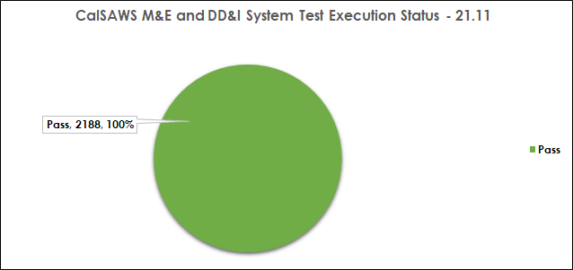
Table 4.4.1-3 – CalSAWS System Change Request (SCR) Test Status
Pass Rate Target as of November 26, 2021 | 0%
Pass Rate Actual as of November 26, 2021 | 0%
System Test Complete Date: January 17, 2021

Figure 4.4.1-4 – CalSAWS System Change Request (SCR) Test Status

- Continued 22.01 Test preparation. Test Execution start date is November 29, 2021

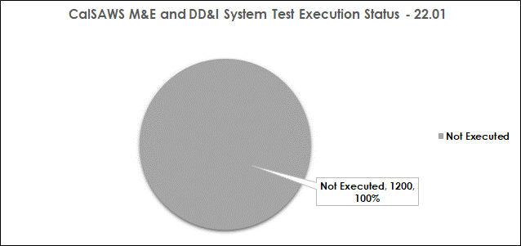
Note: Test script counts are subject to change as test scripts are added or removed throughout the execution phase
- The above chart is cumulative of CalSAWS Modifications & Enhancements (M&E) and CalSAWS Design, Development, and Implementation (DD&I) System Change Requests (SCRs) System Test Execution

Table 4.4.1-5 – CalSAWS GA/GR Correspondence System Test System Change Request (SCR) Test Status

Pass Rate Target as of November 28, 2021 | 0%
Pass Rate Actual as of November 28, 2021 | 0%
System Test Complete Date: January 19, 2022

Figure 4.4.1-6 – CalSAWS GA/GR Correspondence System Change Request (SCR) Test Status

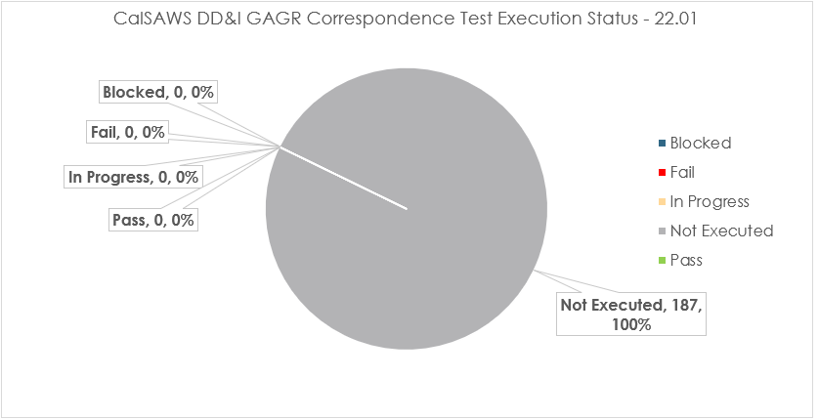

- Gainwell Technologies GAGR Correspondence Service
  - 187 scenarios have been identified and are pending execution

Automated Regression Test (ART) Coverage

Table 4.4.2-1 – CalSAWS Automated Regression Test (ART) Coverage
Production Transactions |  |  |  | ART Coverage by Production Volume
Tier | Distinct | Volume | % Vol. | Distinct | % Coverage
1 | 15 | 80,077,973 | 45.10% | 15 | 100.00%
2 | 105 | 61,916,523 | 34.87% | 98 | 89.51%
3 | 122 | 17,811,009 | 10.03% | 110 | 91.78%
4 | 454 | 14,848,526 | 8.36% | 249 | 62.69%
5 | 2744 | 2,912,684 | 1.64% | 388 | 25.78%

- Note: Transaction volume and coverage metrics are based on CalSAWS monthly production performance data as of October 31, 2021, and Automated Regression Test (ART) coverage data as of September 30, 2021. Each tier is distinct from prior tier(s). For example, tier 2 includes all transactions that make up the top 80% of production volume except for the fifteen tier 1 transactions. Production statistics are updated each month, and coverage statistics are updated with each major release as new automated regression scripts are developed. To date, there are 538 end-to-end Automated Regression Test (ART) scripts

- Note: Production transaction volumes and patterns are expected to fluctuate as the former C-IV Counties transition into CalSAWS. For example: Viewing and updating security roles and groups; reviewing and updating Office, Unit, and Worker data transactions are expected to be higher than normal. This will lead to inaccurate Automated Regression Test (ART) high usage volume transaction coverage reporting. In November the production usage pattern is expected to stabilize, allowing for more precise high usage volume transaction Automated Regression Test (ART) coverage reporting

Training Materials Update
- Online Help System Change Requests (SCRs) for 22.01 are in System Test
- Started 22.03 Impact Analysis
- Hosted Weekly CalSAWS Training team meetings on November 18, 2021
- Web Based Training (WBT) System Change Requests (SCRs) for 21.01-21.07 created and being assigned
- Training Environments
  - Continued to work cross-team to troubleshoot CalSAWS Training Staging and Training Production environment tickets
- Learning Management System (LMS)
  - Continued to work cross-team to troubleshoot CalSAWS Learning Management (LMS) Tickets
  - Continued training for Learning Management System (LMS) support to the Consortium Training team

Figure 4.5-1 – Weekly Training SCR Status Report

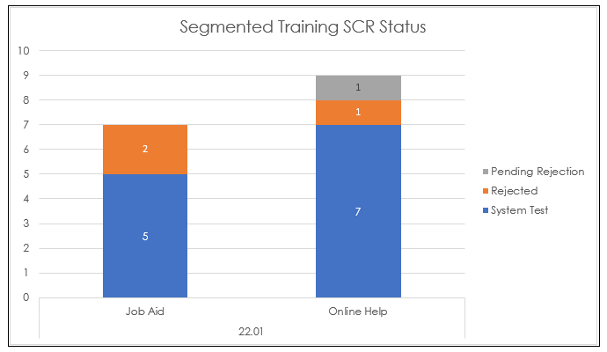

Table 4.5-2 – Upcoming Training Activities
Training Activity | Date
21.11 Code Deployment for Training Staging and Training Production environments | November 22, 2021 (Completed)
21.11 Code Deployment for TR1 Environment | November 23,2021 (Completed)

Deviation from Plan/Adjustments
- None for the reporting period

Regional Updates

Region 1 (Alameda, Contra Costa, Marin, Monterey, Napa, San Benito, San Mateo, San Francisco, Santa Clara, Santa Cruz, Solano, Sonoma)
- Alameda County
- No updates during this reporting period
- Contra Costa County
- No updates during this reporting period
- Marin County
- No Updates during this reporting period
- Monterey County
- No updates during this reporting period
- Napa County
- No updates during this reporting period
- San Benito County
- No updates during this reporting period
- San Francisco County
  - The County elected a new Deputy Director of their Economic Support and Self Sufficiency Division
  - Beginning November 2021, staff must come into the office at least 40% of their work week
  - Planning is underway to prepare for the To-Be sessions in April 2022
  - Continuing to evaluate their high-priority ancillary and peripheral systems to determine whether to adopt to CalSAWS solution or keep, and if keeping what retrofit work is needed
- Santa Cruz County
- Preparing for the To-Be BPR sessions
  - The County has completed orientation for all of their participants and have begun the early Self-Education piece of reviewing material
  - The County is meeting this Wednesday with the Training team for their first county- specific discussion to begin planning training
- San Mateo County
  - No updates for this reporting period
- Sonoma County
  - The County is beginning their training implementation planning for migration
  - The County is carrying on with work on data conversion and cleanup activities.
  - The County Staff are continuing to be introduced to CalSAWS via the demo videos and targeted topic videos
  - HSD continues to work with consultant firm C!A to implement service delivery model changes for their Economic Assistance Division that will allow them to better meet the needs of clients and make changes with an eye to their future with CalSAWS
- Solano County
  - Solano County CalSAWS Advisory Team provided a CalSAWS update and introduction of BenefitsCal at their HSS E&E All-Staff and Managers meetings
  - Bureau Unit Meetings were conducted by the Solano County CalSAWS Advisory Team where they provided an overview of enhancements and an introduction to CalSAWS over the past few months
  - Data Cleansing efforts are continuing with good progress being made
  - CalSAWS Training Videos/Demos were loaded to the CalSAWS and Systems SharePoint site for County staff to view
  - CalSAWS system self-education is underway in preparation for formal “To-Be” County sessions
  - TPOC and IPOC have been identified

Region 2 (Alpine, Amador, Calaveras, El Dorado, Mono, Nevada, Placer, Sacramento, Sierra, Sutter, Tuolumne, Yolo, Yuba)
- Alpine County
  - No updates during this reporting period
- Amador County
  - No updates during this reporting period
- Calaveras County
  - No updates during this reporting period
- El Dorado County
  - No updates during this reporting period
- Mono County
  - No updates during this reporting period
- Nevada County
  - No updates during this reporting period
- Placer County
  - Placer County has named a new Director and are going to be recruiting for a new Deputy Director
- Sacramento County
  - No updates during this reporting period
- Sierra County
  - No updates during this reporting period
- Sutter County
  - No updates during this reporting period
- Tuolumne County
  - The County is working through migration with low staff numbers
- Yolo County
  - Yolo County has increased their in-office support, however, still are limiting customers in the office to one at a time
- Yuba County
  - Currently in hiring processes - 1 Social Worker and 1 Bilingual-Spanish Social Worker who administer and work with the Welfare to Work (WTW) parents
  - Currently in hiring process – 1 Employment and Training Specialist assigned to the YubaWORKs Job Prep and Guidance Center for Job Club instruction along with other Welfare to Work (WTW) Workshops and activities
  - TANF WINS WPR Review by CDSS in December 2021
  - Selected Employment Services staff to attend the CalWORKs Training Academy in December 2021
Region 3 (Butte, Colusa, Del Norte, Glenn, Humboldt, Lake, Lassen, Mendocino, Modoc, Plumas, Shasta, Siskiyou, Tehama, Trinity)
- Butte County
  - The County Currently has a training class of 4 right now and just opened the EW recruitment again with plans to interview in mid-December
- Colusa County
  - The County has a training class of 6 right now. When the trainees graduate, that will double the staff size
- Del Norte County
  - The County has many new staff in training right now and are currently losing experienced staff to other county positions.
  - The County is preparing for a CalWORKs audit and IEVS audit
- Glenn County
  - The County is preparing for the Management Evaluation and WPR Audits that are upcoming
  - The County is short staffed and currently hiring for ETW and a Manager II. The County will be opening Eligibility Worker positions again soon
- Humboldt County
  - Due to short staff, starting on December 1, 2021, the County will be temporarily closing the County Call Center on Wednesdays
  - The County has a current recruitment for Eligibility Specialist and a class of 3 Eligibility Specialists that will graduate soon
- Lake County
  - No updates for this reporting period
- Lassen County
  - No updates during this reporting period
- Mendocino County
  - Currently hiring for Program Specialists, ETWs, Clerical and Eligibility Workers.
  - Lobby opened to the public on November 15, 2021
  - Offering Anxiety Classes for Reopening for staff
- Modoc County
  - Recently hired 2 office specialists to cover the front office so eligibility staff and supervisors do not have to cover the front desk
  - Currently short staffed in eligibility
- Plumas County
  - The County has an open recruitment for Eligibility Worker and CalWORKs supervisor
- Shasta County
  - The County is down about 30+ Eligibility Workers. It has a continuous recruitment for Eligibility Workers and are conducting exams and interviews every two weeks. Beginning December 6, 2021, it will have three training classes going on
  - The County has a new Director who was promoted from the Deputy Director position and is familiar with CalSAWS
- Siskiyou County
  - No updates during this reporting period
- Tehama County
  - Due to being short staffing and not having enough Clerical Staff to cover two offices, the Corning Office was closed beginning November 22, 2021. Staff will relocate to the Red Bluff office on December 6, 2021. The County will revisit reopening the office in mid- January
- Trinity County
  - The County currently has a continuous recruitment, is waiving the written test, and reaching out to retirees for extra help
  - Telecommuting is also being discussed at executive management level
Region 4 (Fresno, Inyo, Kern, Kings, Madera, Mariposa, Merced, San Joaquin, San Luis Obispo, Stanislaus, Tulare)
- Fresno County
  - Virtual Welfare-to-Work Orientation
    - Fresno County Department of Social Services (DSS) has implemented a virtual Welfare to Work (WTW) Orientation option for WTW participants. All participants now have the option of creating an account through DSS PASS and review their orientation and all materials related to the orientation online. In order to utilize the Virtual WTW Orientation option via DSS PASS, the participant must have access to the internet, through a computer or a smart cell phone, access to an email account, and must create an account in DSS PASS
  - DSS Director Announces Departure
    - After seven years of service to the County of Fresno, the Director of the Department of Social Services has announced he will be leaving the County effective December 10, 2021
    - Under his leadership, the Department of Social Services helped more than 1,000 children get adopted and more than 1,000 children were safely returned to their parents. The department helped develop new homeless services that included housing and added an additional 50,000 residents who accessed some form of public assistance. 11 Neighborhood Resource Centers were established, especially in rural communities, and vast improvements were made to all constituent services and with the move to the newly designed facilities at the centralized Clovis campus
    - Prior to his service at Fresno County, he worked for Kern County and Santa Barbara County
    - During his time with the County, the Department of Social Services has stepped into the 21st century with innovative technology and significantly upgraded facilities that not only improved services to the residents in the County, but also improved employee morale. He led the department throughout the pandemic and Creek Fire, continuing to provide crucial services to those in need. The County is grateful for his many contributions and vision,” stated Jean Rousseau, the County Administrative Officer
- Inyo County
  - No updates during this reporting period
- Kern County
  - The County has been meeting with the BPR vendor contracted by the State for the initial assessment. The next step will be to receive their assessment and recommendations
  - The County is looking forward to the extended support meeting scheduled for Kern
  - The County has started a new training class, which is a combination of virtual and in- person instruction. The training has lessened the time to get staff on the floor
  - The County is planning for the return of the Delano staff to the Delano office sometime after the 1st of December after the fire in the lobby
  - The County has received two grants to focus on CalFresh outreach and will be reaching out to the Project to assist in the development of equipment that can be used out in the field
- Kings County
  - No updates during this reporting period
- Madera County
  - No updates during this reporting period
- Mariposa County
  - The County is fully staffed and is continuing to work to increase their understanding of CalSAWS and the Imaging solution. Due to majority of Staff out for the Holidays, there will be minimal trainings this time of year
- Merced County
  - No updates during this reporting period
- San Joaquin County
  - No updates during this reporting period
- San Luis Obispo County
  - The Program Manager for Participant Services Training retired in November 2021 and a new Employment Services Supervisor was appointed into the role and will also be joining the CalSAWS Steering Committee
  - The CalSAWS Steering Committee will celebrate one year of work on December 15, 2021 and will reflect on their progress with communications to staff in the form of newsletters and videos. In addition, there will be a creation of workgroups to lead staff through upcoming business process changes. There is more to come including the Business Process Reengineering sessions in May/June of 2022
- Stanislaus County
  - No updates during this reporting period
- Tulare County
  - No updates during this reporting period

Region 5 (Imperial, Orange, Riverside, San Bernardino, San Diego, Santa Barbara, Ventura)

- Imperial County
  - No Updates during this reporting period
- Orange County
  - The County has implemented their Countywide Operation Santa Claus program. They collect gifts and toys for children who are receiving benefits through Foster Care and also for children of disadvantaged Parents
  - The County has added two additional Mobile Response Vehicles (MRVs) to expand their outreach fleet. They have a total of three MRVs which are available for community outreach and emergency response
- Riverside County
  - Has returned to in-person eligibility training
- San Bernardino County
  - The County continues to have great success with the Automated Assistants. For the period of November 8-14, it had the following outcomes:
    - Authentication Automated Assistant – 85% of callers were successful authenticating
    - Welcome Automated Assistant – 79% success rate in identifying the “intent” of the call
    - Push Notification Automated Assistant – 16% callers ended the call after receiving the Push Notification
- San Diego County
  - San Diego County is in the final stages of hiring a new CalSAWS Implementation Support unit. The unit will consist of 4 new Program Specialists. This new team will work on conversion activities like clean-up lists, communication with line staff, CalSAWS CITs and CRFIs, and any Implementation Support Services (ISS) items as they arise
- Santa Barbara County
  - Santa Barbara County is in the review process for their To-Be Sessions and plan to complete this effort by mid-December
- Ventura County
  - The County has kicked off their County Spark of Love Drive which collects toys, as well as food donations, for families in need
  - The County is still going through their BPR process for their To-Be sessions
  - The County had to recently close a high-volume public site due to unexpected facilities issues. Through this experience were able to transition quickly to serving clients virtually and in-person at alternate sites
  - Has allowed the County to check their service strategy during disaster events to better serve their community and their staff
Region 6

- Los Angeles County
  - The CalSAWS Support Section (CSS) Release Team is preparing for Release 22.01
  - Focus Groups were held November 29, 2021, and November 30, 2021
  - Recruitment of Department of Public Social Services (DPSS) County Validators was completed and the Orientation meeting to onboard County Validators is scheduled for December 9, 2021
  - CSS Release Team will begin validation on December 6, 2021
  - County Validation will start December 13, 2021 – December 27, 2021
- Change Management communication activities for Imaging and BenefitsCal continue in Los Angeles County pending confirmation of new go-live date
- DPSS recruitment is underway for volunteer tax preparers for the Department’s 2022 Volunteer Income Tax Assistance (VITA) Program. VITA volunteers help low-income CalWORKs and CalFresh families receive hundreds of dollars in tax credits. This year, VITA Program volunteers helped more than 109 families receive an average tax refund of $2,400
- DPSS Adopt-A-Family Program is also underway. It is a Program that benefits DPSS customers receiving CalWORKs, CalFresh, Medi-Cal or IHSS services. LA County employees and partners can sponsor a family. Sponsorship applications are now available online via https://bit.ly/DPSSAAF (DPPS website>Community Service> Volunteer Services>Adopt-A-Family Program). The Deadline to sponsor a family is December 21, 2021
- Los Angeles County Department of Children and Family Services (DCFS) Director has announced his resignation, effective December 31, 2021. A new DCFS Chief Deputy will be taking over for him in an acting capacity until someone is selected to fill the position. Another interim Chief Deputy Director will be Filling the Chief Deputy role behind the previous one

Appendices

Appendix A – M&E Requests and SCR Status
Appendix B – County Purchases Status Report
Appendix C – CalSAWS System IVR Report
Appendix D – COVID SCRs

