CALSAWS M&O BI-WEEKLY STATUS REPORT
Reporting Period: November 29, 2021 – December 12, 2021

Table of Contents
1.0 Executive Summary 4
1.1 CalSAWS Project Status Dashboard 4
1.2 Highlights from the Reporting Period 6
2.0 Project Management 6
2.1 Project Deliverables Summary 6
2.2 Highlights for the Reporting Period 7
2.3 CRFI/CIT Communications Status 7
2.4 SCIRFRA/SCERFRA/SIRFRA/SARRA Information 9
2.5 Deviation from Plan/Adjustments 10
3.0 Maintenance and Operations 11
3.1 Service Management 11
3.1.1 Overview 11
3.1.2 CalSAWS Help Desk Metrics 12
3.2 Technology Operations 16
3.2.1 CalSAWS Management and Operations 16
3.2.2 Service Level Agreement (SLA) Outcomes (Met/Missed) (CalSAWS) 17
3.3 Production Defect Backlog 18
3.3.1 Release Schedule Production Defect Fix 18
3.4 Production Operations 19
3.4.1 Release Communications 19
3.4.2 Root Cause Analysis (RCA) 19
3.4.3 Batch Operations 20
3.5 ForgeRock 20
3.6 Innovation Lab 21
3.7 Imaging 21
3.8 Customer Service Center (CSC) 22
3.9 IVR Bot Enhancement Pilot for San Bernardino County 22
3.10 Deviation from Plan/Adjustments 22
4.0 Application Development 23
4.1 Priority Release Summary 23
4.2 Application Development Status 25
4.3 Release Management 26
4.3.1 Release Test Summary 26
4.3.2 Automated Regression Test (ART) Coverage 27
4.4 Training Materials Update 28
4.5 Deviation from Plan/Adjustments 29
5.0 Regional Updates 29
6.0 Appendices 29

Executive Summary

CalSAWS Project Status Dashboard
Table 1.1-1 – Status Dashboard

Topic | CalSAWS System | Highlights
Availability |  | - The CalSAWS System did not experience any unplanned outages
Defects |  | - There are 226 active Production defects
Incidents |  | - CALSAWS BROADCAST: Starting at 8:00 p.m. on November 18, 2021, incoming calls and courtesy callback calls in the Amazon Connect Contact Center were intermittently failing to connect, or customers were unable to hear the agent. Calls that fail to connect were automatically routed to a different agent. As of 6:00 a.m. on November 27, 2021, the issue has been resolved. Project team continues to monitor the call connectivity.  - Impacted Counties: San Bernardino, Riverside, Kern, Kings, Stanislaus, Marin, Humboldt, Butte, Yuba, Sutter, Monterey, San Joaquin, Merced, and Shasta.  - CALSAWS BROADCAST: Starting at 8:00 a.m. on November 29, 2021, the Reception Logs displayed an error message when attempting to perform a Lobby Monitor Call. As of 4:30 p.m. on November 30, 2021, the issue has been resolved.  - CALSAWS BROADCAST: As of 2:40 p.m. on December 1, 2021, the C-IV Read Only environment was unavailable for users. As of 5:45 p.m. on December 1, 2021, the issue has been resolved and users were able to access the C-IV Read Only environment.  - CALSAWS BROADCAST: Some documents in system queues were backlogged during processing. The Hyland vendor identified the issue was due to high memory usage in the conversion process. As of 12:00 a.m. on December 2, 2021, this issue has been resolved. All the backlogged documents have been successfully processed.  - CALSAWS BROADCAST: Starting at 7:40 a.m. on December 6, 2021, users were experiencing connectivity issues with FIS (EBT Vendor) causing Electronic Benefit Transfer (EBT) transactions to timeout and fail. Users were unable to print EBT cards or perform EBT related transactions. Both CalSAWS and CalWIN Counties were impacted by this issue. As of 9:51 a.m. on December 6, 2021, the issue was resolved. The Project team continues to monitor the connectivity.  - CALSAWS BROADCAST: Starting at 12:00 p.m. on December 8, 2021, users were experiencing slowness and page timeouts while performing transactions in CalSAWS. As of 4:24 p.m. on December 8, 2021, the issue has been resolved. The project team has observed a stable system performance since then and continued to monitor the system.  - On December 9, 2021, some users from San Bernardino County may have experienced issues logging into the CalSAWS application. The project team resolved the issue by 10:00 a.m. on December 9, 2021 and confirmed that the users from San Bernardino County were able to login.  - On December 10, 2021, some Los Angeles County users were unable to process Electronic Benefit Transfer (EBT) cards. The FIS EBT vendor had been notified and was troubleshooting the issue. As of 11:00 a.m., the FIS EBT vendor has resolved the issue. Los Angeles County users were then able to print Electronic Benefit Transfer (EBT) Cards.
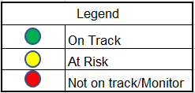

Highlights from the Reporting Period

- The CalSAWS team successfully deployed CalSAWS minor releases 21.11.30, 21.12.01, 21.12.02, 21.12.03, 21.12.06, 21.12.07, and 21.12.08 to CalSAWS production
- Planned Outages:
  - Scheduled CalSAWS Outages:
CalSAWS Production Outage – on November 29, 2021, from 8:30 p.m. until 8:55 p.m. During this period, users were unable to access the CalSAWS application.
  - CalSAWS Production Maintenance – on December 5, 2021, from 6:00 a.m. to 4:00 p.m. Users may have experienced intermittent connectivity issues. If users experienced an issue while logged into CalSAWS, they were instructed to log out and try to login again.
  - CalSAWS Production Maintenance – on December 5, 2021, from 4:00 p.m. to 8:00 p.m. Users were unable to access the CalSAWS application. Users were redirected to a “Read Only” version of the CalSAWS application.
- Scheduled External System Outage:
  - (Your Benefits Now) YBN and BenefitsCal in Offline Mode – on November 29, 2021, from 8:30 p.m. until 8:55 p.m. During this period, transactions were queued and were processed upon completion of maintenance activities and participants were not able to view Electronic Benefit Transfer (EBT) balances and case information. Electronic Benefit Transfer (EBT) balance and case information was not available to view from YBN or from BenefitsCal.
  - YBN and BenefitsCal in Offline Mode – on December 05, 2021, from 04:00 p.m. During this period, transactions were queued and were processed upon completion of maintenance activities and participants were not able to view Electronic Benefit Transfer (EBT) balances and case information. Electronic Benefit Transfer (EBT) balance and case information was not available to view from YBN or from BenefitsCal

Project Management

Project Deliverables Summary
Table 2.1-1 – Overall Summary of Deliverable Status for Current Reporting Period

DEL # | DELIVERABLE NAME | TEAM | STATUS ^{[1]} | STATUS
None
[1] Status: Green: On schedule, performing as planned; Amber: Potential delay/monitor with no material schedule impact; Red: Behind schedule and requires escalation

Highlights for the Reporting Period
- Continued Project administration, facility management, office management support, and financial management tasks
- Continued supporting the SOC 1 audit for the State Fiscal Year 2020/21 review period
- Continued performing contract management activities:
  - Updated and finalized the documents for contract Change Notice No. 13, which addressed comments from the Consortium’s review. Change Notice No. 13 will be submitted to the CalSAWS JPA Board of Directors for approval on December 17, 2021 and include the following:
    - Use of the contract’s R&A Change Budget Services allocation for CDSS reports support, enhancements related to CalSAWS correspondence, and additional CalSAWS Modifications and Enhancements (M&E) hours for State Fiscal Year 2021/22
    - Technical updates to Schedule 2 to Exhibit X, the Statement of Work for the CalSAWS DD&I Project, to reflect the final approved deployment schedule for Non-State Forms
    - Technical updates to Schedule 15 to Exhibit X, the Statement of Work for the CalSAWS Customer Service Center Project, to reflect the current approved schedule for design activities
  - Tracking of County Purchases:
    - Reference Appendix B for detailed tracking of County Purchases

CRFI/CIT Communications Status

- The following table outlines CalSAWS Information Transmittals (CITs) for the reporting period ending December 12, 2021

Table 2.3-1 – CITs

CIT ID | Subject | Category | Distribution Date | Primary  CalSAWS Contact | Backup  CalSAWS Contact
0349-21 | CalSAWS Imaging – Remote Work Best Practices | Informational | November 30, 2021 | Chris Vasquez | Toby Barnes
0353-21 | CA-216745 List of Verified Blank Social Security Numbers | Informational | December 1, 2021 | Caroline Bui,  Sarah Cox,  Nina Butler,  Ignacio Lázaro, and  Adelaide Mendoza | Binh Tran,  Elisa Miller, and  Laura Ould
0354-21 | ACIN I-64-21 2022 State Minimum Wage Batch Memorandum | Informational | December 2, 2021 | Caroline Bui | Binh Tran
0355-21 | Monthly CalSAWS De-Duplication Report Posted | Informational | December 6, 2021 | Cristy Sharma | Paul Trisler
0356-21 | CA-233836 2022 SSA COLA Data Changes Posted Lists | Informational | December 6, 2021  Revised  December 8, 2021 | Caroline Bui,  Sarah Cox,  Nina Butler, and  Ignacio Lázaro | Binh Tran,  Maggie Orozco-Vega, and  Laura Ould
0357-21 | CA-236019 CalFresh Emergency Allotments for November 2021 List Posted | Informational | December 8, 2021 | Caroline Bui | Binh Tran
0358-21 | CalSAWS Migration User Acceptance Test Areas | Informational | December 8, 2021 | Peggy Macias | Rachel Hernandez
0359-21 | CalSAWS Imaging Document Manipulation and Routing Logic Infographics | Informational | December 9, 2021 | Helen Cruz | Araceli Gallardo
0360-21 | Scheduled Downtime Notification | Informational | December 10, 2021 | Mike Tombakian, and  Anand Kulkarni | Grady Howe, and  Ted Anderson
0361-21 | CA-232611: List of cases that have been discontinued due to reason of ‘Gets Duplicate Aid’ from 11/10/21 – 12/08/21 | Informational | December 10, 2021 | Elisa Miller | Nina Butler

- The following table outlines CalSAWS Requests for Information (CRFIs) for the reporting period ending December 12, 2021

Table 2.3-2 – CRFIs

CRFI ID | Subject | Distribution Date | Status | Response Due Date | CalSAWS Contact
21-066 | Updating CalSAWS County Fiscal Contact Information | November 17, 2021 | Closed | December 8, 2021 | Chia Thao
21-067 | NA 791 Post Adoptions Services (PAS) Phone Number | November 22, 2021 | Closed | December 3, 2021 | Ignacio Lázaro
21-068 | 1099 Interface Schedule Option | November 23, 2021 | Open | December 13, 2021 | Sheryl Eppler
21-069 | CalWIN Implementation Point of Contact (IPOC) Identification | December 3, 2021 | Open | December 13, 2021 | Melanie Wolfley
21-070 | Change Network Champion (CNC) Identification for Wave 1 and 2 Counties | December 6, 2021 | Open | December 17, 2021 | Helen Cruz
21-071 | CA-218788 Migrate CalWIN Districts and Regions to the Office Detail page | December 9, 2021 | Open | January 7, 2021 | Dymas Pena
21-072 | Interface Partner Testing Contacts Confirmation for CalWIN Wave 1 Counties | December 10, 2021 | Open | January 14, 2021 | Carlos Zepeda

Table 2.3-3 – Overdue CRFIs

- The following table outlines overdue CalSAWS Requests for Information (CRFIs) for the reporting period ending December 12, 2021

CRFI ID | Subject | Region 1 | Region 2 | Region 3 | Region 4 | Region 5 | Region 6
None

SCIRFRA/SCERFRA/SIRFRA/SARRA Information

- The following tables outline current CalSAWS SAWS Communication Information Request for Research and Analysis (SCIRFRA), SAWS Cost Estimation Request for Research and Analysis (SCERFRA), SAWS Information Request for Research and Analysis (SIRFRA), and SAWS Advocates Request for Research and Analysis (SARRA)

Table 2.4-1 – Summary of SCIRFRA/SCERFRA/SIRFRA/SARRA Requests
Status | Total
Rejected | 1
Assigned | 9
Completed | 555
Duplicate | 17
Withdrawn | 20
Pending Clarification | 1
Total | 603

Note: SCIRFRA/SCERFRA/SIRFRA/SARRA requests from November 2018 through the end of the reporting period

Table 2.4-2 – Details of SCIRFRA/SCERFRA/SIRFRA/SARRA Data Received
ID | Description | Status | Due Date | Response Received Date | Notes
21-546 | 21-546 MEDS Modifications | Pending Clarification | November 18, 2021 | No response
SIRFRA 3696 | 3696 – CalWORKs Application, Redetermination, and Closed Cases | Completed | December 2, 2021 | December 2, 2021
SIRFRA 1161 | 1161 – RMR Data Questions | Completed | December 3, 2021 | December 1, 2021
SCERFRA 21-547 | 21-547 – Redetermination Reminder NOA | Completed | December 3, 2021 | December 3, 2021
SIRFRA 3704 | 3704 – CalFresh SSI Queries 1 & 2 | Assigned | December 10, 2021 | No response
SIRDRA 3706 | 3706 – Revided CCP 2145 | Assigned | December 13, 2021 | No response
SIRFRA 3713 | 3713 – King-GAP Payments March 2020 Through June 2021 | Assigned | December 15, 2021 | No response
SIRFRA 3708 | 3708 – Adoption of IRT and Budget on Approval and Denial on Restoration NOAs | Assigned | December 17, 2021 | No response
SIRFRA 1162 | 1162 – CMS PI May 2021 Data | Assigned | December 20, 2021 | No response
SIRFRA 3699 | 3699 – Stage One Child Care Home Provider Data | Assigned | December 20, 2021 | No response
SIRFRA 3705 | 3705 – Voluntary Contribution | Assigned | December 22, 2021 | No response
SIRFRA 3710 | 3710 – CalFresh Confirm Data Pull | Assigned | December 23, 2021 | No response
SIRFRA 3712 | 3712 – Direct Outreach Project for CDSS Clients | Assigned | January 3, 2022 | No response

Deviation from Plan/Adjustments
- None for the reporting period

Maintenance and Operations

Service Management

Overview

- Configuration Management Database (CMDB) project development of Proof of Concept (POC) continues to determine the discovery footprint. The mid-tier polling agent has been established in Amazon Web Services (AWS) development and data has been established in the system. The AWS Cloud Discovery Proof of Concept (POC) is in place. Currently working on Horizontal Discovery.
- Consortium Security team has a request for Change Process Hardening for the Technical Change Management. Development is on hold awaiting requirements associated to fielding
- Innovation hub’s application status page solution and technical architecture have been completed. A meeting will be held on December 16, 2021 to finalize requirements and backend integration details. The ServiceNow frontend has been developed and also needs requirements finalized.
- Completed - Cherwell bi-directional integration has been completed and validated. A minor defect has been confirmed and an emergency change will be created to fix the issue next week
- The Data Source requested second phase will be the creation of workflows for each of the requests to automatically handle distribution to teams. Working with the teams on requirements associated to workflows.
- ForgeRock and ServiceNow integration discussions of requirements underway

Figure 3.1-1 ServiceNow Timeline

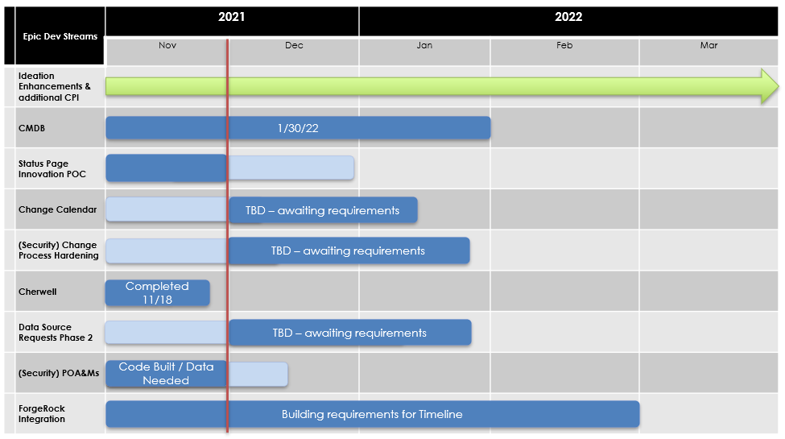

CalSAWS Help Desk Metrics

Figures 3.1.2-1 and 3.1.2-2 – CalSAWS ServiceNow Cases per Week

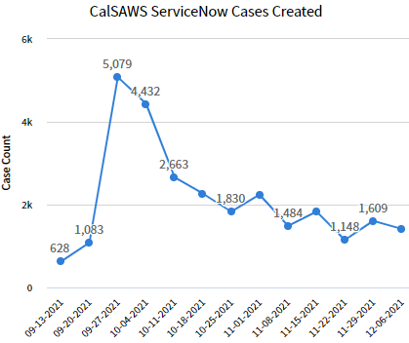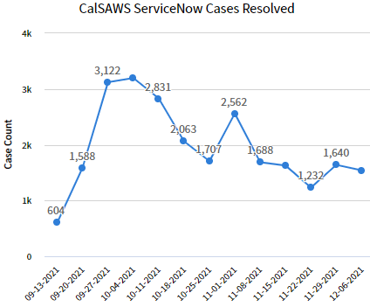

Note: The graphs represent the ServiceNow cases associated to all 40 Counties. Cases represent the
first level of ticketing that enters the ServiceNow system. The dates in x-axis represent the start of week
Figures 3.1.2-3 and 3.1.2-4 – CalSAWS ServiceNow Incidents

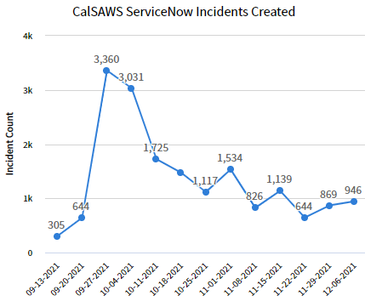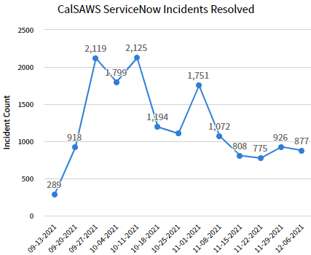

Note: The graphs represent the ServiceNow Incidents associated to all 40 Counties. Incidents are escalations derived from case attempts to triage the issue. The dates in x-axis represent the start of a week.

Figures 3.1.2-5 and 3.1.2-6 – CalSAWS ServiceNow Problems

Note: The graphs represent the ServiceNow problems associated to 40 Counties. Problems represent issues that can have a many to one relationship with incidents and the final step in escalation. The dates in x-axis represent the start of a week.

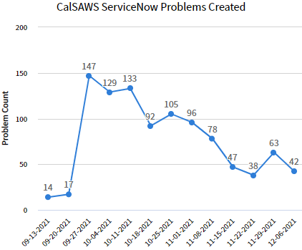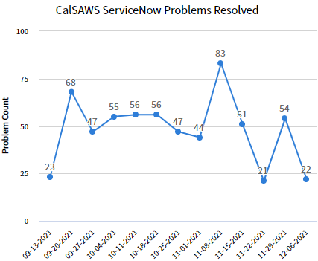

Figure 3.1.2-7 – CalSAWS ServiceNow Incidents by State and Age

Note: In the pivot table below, the (empty) aging category represents tickets less than a day old.

 | <1  Day | 1-5 Days | 6-10 Days | 11-15 Days | 16-30 Days | 30-60 Days | 60-180 Days | >180 Days | Total
New | 47 | 186 | 53 | 12 | 23 | 16 | 1 | 0 | 338
In Progress | 7 | 155 | 131 | 128 | 170 | 180 | 42 | 0 | 813
On Hold | 5 | 137 | 104 | 159 | 362 | 628 | 381 | 129 | 1,905
Resolved | 6 | 148 | 267 | 429 | 623 | 376 | 77 | 0 | 1,926
Closed | 0 | 1 | 3 | 5,086 | 13,130 | 3,264 | 1,053 | 4 | 22,541
Problem in Diagnosis | 0 | 6 | 1 | 1 | 55 | 2 | 3 | 0 | 68
Total | 65 | 633 | 559 | 5,815 | 14,363 | 4,466 | 1,557 | 133 | 27,591

Figure 3.1.2-8 – CalSAWS ServiceNow Incidents by Resolution Code

Note: The pie chart below represents Incidents resolved within the past 2 months.

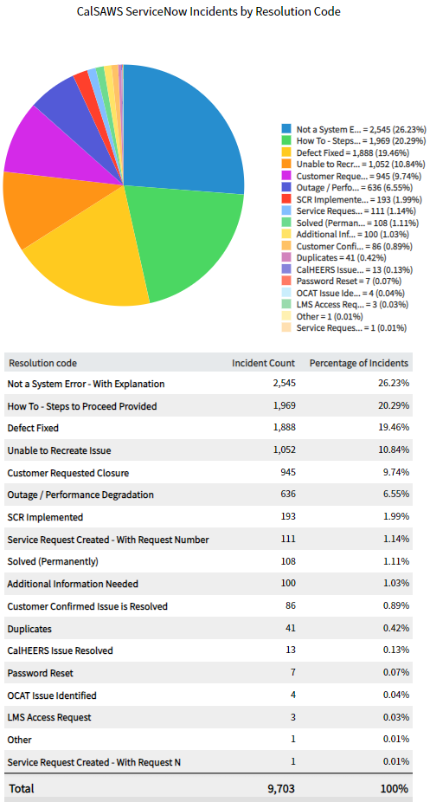

Figure 3.1.2-9 – CalSAWS ServiceNow Incidents Created by Category
Note: The pie chart below represents Incidents by Category created within the past 2 months.
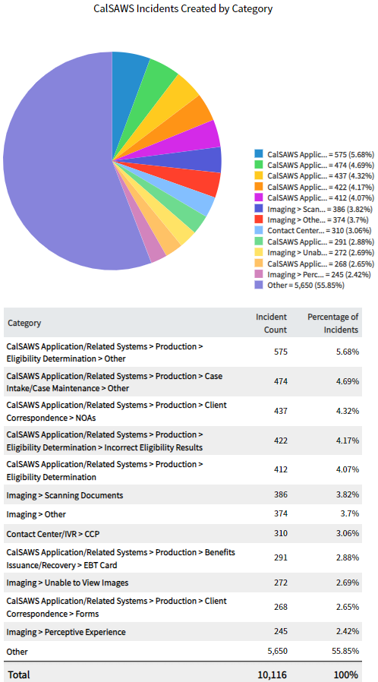

Figures 3.1.2-10 – CalSAWS ServiceNow Cases Created for Remote Maintenance

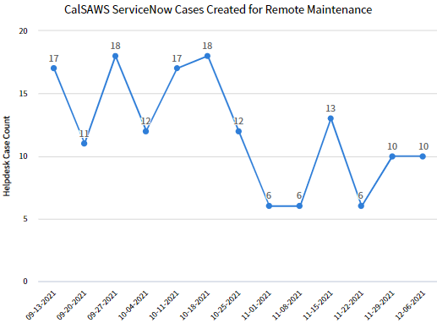

Technology Operations
The CalSAWS Technology team provides technical infrastructure support for the deployment of system changes and system maintenance activities in accordance with the CalSAWS Change Control Process. Technical infrastructure support activities include configuration and setup of development and non-Production environments for work items, infrastructure (middleware and database)/architecture changes, promotion of application builds through the development stages, and deployment of application builds into the CalSAWS Production environments

CalSAWS Management and Operations

- Switch Automation
  - Switch Refresh completed for 71% of sites, with 71% of total devices completed across the sites (416 of 582 switches)
  - Switch Refresh for site 13002 (Imperial) planned
  - Switch Refresh for site 24001 (Merced) completed
- Remote Connectivity
  - ZScaler Design in Progress
  - Enhancement of Security for CalSAWS Equinix Virtual Private Network (VPN) completed at SV1
- C-IV Data Center Decommissioning
  - Completed SV1 Data Center build and server connectivity enablement to support Production Data Center decommission
  - LA3 Design to start January 2022
  - Production Data Center decommission
    - Starting prep work on December 14, 2021
    - Physical decommission and shredding to start week of December 27, 2021
    - Target completion is December 31, 2021

Table 3.2.1-1 – CalSAWS Upcoming Maintenance
Scheduled Date | Activity Description
December 15, 2021 | Reducing Session Timeout on VPN Devices (Planned Change)
December 16 - 20, 2021 | VeloCloud 3.4.6 Firmware Upgrade – Wave 2 (Planned Change)
December 17, 2021 | ForgeRock Production Release 21.12.17
December 19, 2021 | October 2021 Database Patching on Production Databases
December 19, 2021 | Production Linux Operating System (OS) Patching December 1, 2021 Patch Baseline
December 24 - 26, 2021 | October 2021 Database Patching on PRT (Policy, Review, Training), County Preview, Training and Sandbox Databases
January 2, 2022 | Production Database Amazon Web Service (AWS) Linux Operating System (OS) Patches December 1, 2021, Patch Baseline (CalSAWS Outage needed from 4:00 p.m. – 8:00 p.m.)

Table 3.2.1-2 – CalSAWS Incident Follow-up Summary

Ticket ID | Description | Impact Date / Time | Impact | Resolution
None

Service Level Agreement (SLA) Outcomes (Met/Missed) (CalSAWS)

- The CalSAWS System met all Service Level Agreements (SLAs) within the reporting period

Production Defect Backlog
The Production defect backlog bar-chart depicts the balance of open (unresolved Production defects) and closed defects, week-over-week. Defects are closed upon system test validation and release deployment to Production

Figure 3.3-1 – Production Defects Backlog Weekly Trend
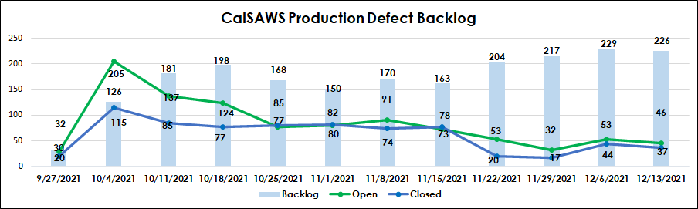

Release Schedule Production Defect Fix

The Production Defect fix – Release Schedule reflects the number of defects planned in alignment to each monthly release (21.01, 21.02, etc.). The status of the defect in the fix and re-test pipeline is also reflected for each of the defect severity categories to establish the number of defects remaining to be fixed, re-tested, and closed for each of the releases

Table 3.3.1-1 – Production Defect Fix – Release Schedule

CalSAWS Production Defect Count by Release
Count of Defects | Release
Severity | 21.11 | 22.01 | 22.02 | 22.03 | TBD | Grand Total
2-Normal/Medium | 17 | 11 |  |  | 1 | 29
New | 3 | 3 |  |  |  | 6
In Progress | 3 | 6 |  |  |  | 9
Closed | 11 | 2 |  |  | 1 | 14
3-Normal/Low | 148 | 170 | 1 | 2 | 7 | 328
New | 3 | 45 |  |  | 5 | 53
In Progress | 27 | 119 | 1 | 2 | 1 | 150
Closed | 118 | 6 |  |  | 1 | 125
4-Cosmetic | 4 | 6 |  | 1 |  | 11
New |  |  |  | 1 |  | 1
In Progress | 1 | 6 |  |  |  | 7
Closed | 3 |  |  |  |  | 3
Grand Total | 169 | 187 | 1 | 3 | 8 | 368
Note: Data Change Requests (DCRs) have been excluded from the above reporting because they follow a separate deployment process

Production Operations

Release Communications
- CalSAWS Release 22.01 Communications:
  - See table 3.4.1-2 for details

Table 3.4.1-2 – CalSAWS Release 22.01 Communication Activities
TASK | DATE(S) | OWNER
Sent Release 22.01 Major Upcoming Changes documentation | December 06, 2021 | Training
end draft Release Notes file to Regional Managers and Consortium Staff for review | December 27, 2021 | Production Operations
Send summary of changes in CalSAWS Release 22.01 in CalSAWS Health Report | January 17, 2022 – January 21, 2022 | Production Operations
Webcast on CalSAWS Release 22.01 | TBD | Production Operations/ Consortium Policy and Design
22.01 CalSAWS Application Development and Training Release Notes Broadcast | January 18, 2022 | Production Operations
CalSAWS Release 22.01 Greenlight Meeting | TBD | Release Management/QA
CalSAWS 22.01 Post-Release Checkpoint Call | January 24, 2022 – January 26, 2022 | Production Operations

Root Cause Analysis (RCA)
- None for the reporting period

Batch Operations
- Planned and executed run of three Cost of Living Adjustments (COLAs) as part of Saturday night’s (December 11, 2021) batch run: SCR CA-233171 – CAPI COLA, SCR CA-233837 SSA COLA, and SCR CA-219831 - State Minimum Wage COLA
- Worked with Monterey, Butte, and Riverside Counties on their connectivity issues and processing of warrant/positive pay files
- Supported nightly batch operations and coordinated with Application Development, Database Administration, and technical teams to resolve issues and performance tune batch jobs
- Supported execution of cyclic/high frequency/Event streaming jobs
- Implemented and Validated Batch System Change Requests (BSCRs)
- Coordinated with Application Development/Database Administration/Technical teams and testing batch performance for Oracle 19C
- Continued working on operations System Change Requests (SCRs) for holiday calendar, Meds Recon, and 10-day cutoff
- Conducted knowledge transfer session for offshore team on monitoring nightly batch operations

ForgeRock
- Reviewed and secured Consortium Accountability Board (CAB) approval for ForgeRock 21.12.17 Production Release
- Reviewed and secured Consortium Accountability Board (CAB) approval for finalizing the onboarding of the CalSAWS Jira application, going live with ForgeRock authentication on December 18, 2021
- Implemented daily ForgeRock/ Consortium Multi-Factor Authentication (MFA) Roll Out meetings as Teams continue to discuss a finalized strategy, timeline, and training plan
- Attended Environment/ Integration Management Review where a request was submitted for BenefitsCal to integrate an additional training environment with ForgeRock, further discussion to be held in the future
- Began work on providing requested ForgeRock User Access Reviews (UARs)
- Submitted Instructions for Logging into CalSAWS Jira and Bitbucket Applications County Information Transmittal (CIT) to CIT Review Committee for feedback
- Continued development work on enabling RADIUS Multi-Factor Authentication (MFA) authentication in Access Manager
- Continued development work on onboarding existing applications outlined in Statement of Work (SOW)

Table 3.5-1 – ForgeRock Milestones

MILESTONES | PROD DEPLOYMENT DATE | STATUS
ForgeRock 21.12 Production Deployment | 21.12.17 | Not started
Automated Delegated Administrator Process Workflow - ForgeRock and ServiceNow​ | 21.12.17 | In progress
Remove Delegated Administrator Entries for Non-Accessible User/Roles​ | 21.12.17 | In progress
Apply Multi-Lingual Knowledge-Based Authentication (KBA) Patch for BenefitsCal defect | 21.12.17 | In progress
ForgeRock Los Angeles County Federated Authentication | 21.12.17 | Postponed
CalSAWS Jira & Bitbucket Single Sign on Login with ForgeRock | 21.12.18 | In progress
ForgeRock Application Onboarding: Adobe Experiences Production clients | 22.01.28 | Complete
Enable Lifecycle Management for ServiceNow Accounts | 22.01.28 | Postponed
ForgeRock Application Onboarding: ZScaler Production clients | 22.01.28 | In progress
ForgeRock Application Onboarding: Consortium AWS Production clients | 22.01.28 | In progress
Enable ForgeRock Multi-Factor Authentication (MFA) capabilities for Project Users & County Users | TBD | In progress

Innovation Lab
- Continued Innovation Lab activities
  - Streamlined CalSAWS Lobby Application (Describe Phase)
    - Continued requirements for lobby application enhancements
  - System Status for End Users (Co-Create Phase)
    - Continued prototype project management timeline and activities
  - CalSAWS Production Calendar (Discovery Phrase)
    - Continued prototype project management timeline and activities
  - Cybersecurity Awareness Program (Discovery Phase)
    - Received initial approval on program approach and received guidance to continue Tech Budget Change Request process

Imaging
- Attended CalSAWS Post-Deployment County Stakeholder call:
  - December 1, 2021, at 4:00 p.m. – 5:00 p.m.
- Scheduled two sessions of Imaging Office Hours to give counties an additional outlet to get their questions answered:
  - December 16, 2021, at 2:30 p.m. – 4:00 p.m.
  - December 17, 2021, at 10:30 a.m. – 12:00 p.m.
- Deployed SCR (December 9, 2021) CA-236864 – Configure Portal Summited Documents to Bypass Optical Character Recognition (OCR) – Documents submitted on the BenefitsCal portal are bypassing OCR
- Continued to work with Counties and project on improving County exception queues

Customer Service Center (CSC)
- Continued designs for the following:
  - SCR CA-234540 – Update Call Control Panel (CCP) Security and Database connection
    - This will ensure agents are able to still login to the Call Control Panel (CCP) and handle calls if there are database issues and implement seamless failover to the standby database if needed. Still in progress
- Continued build of the following:
  - CA-237144 - Outbound IVR for EBT Scam Notification
    - This will notify all customers that have opted into Interactive Voice Response (IVR) notifications and have an active Electronic Benefit Transfer (EBT) card of the multiple scams going on
    - This is scheduled to start making calls on December 29, 2021
- Working with Security team to identify and resolve any issues found from static code scans

IVR Bot Enhancement Pilot for San Bernardino County
- Welcome Bot
  - Welcome Bot continues to successfully route approximately 80% of callers that interact with the bot
  - Push Notification is successfully deflecting approximately 13% of callers from needing to speak to a worker
  - Welcome Bot and Push Notification combined successfully deflect approximately one- third of all callers
- Authentication Bot
  - Authentication rate remains high. Bot is authenticating on average 89% of callers that interact with the bot
- Moving beyond production pilot, taking inventory of future enhancements, upgrades, and customer requests for both Bots. Upcoming meeting with San Bernardino to prioritize, plan, and enable this effort

Deviation from Plan/Adjustments

- None for the reporting period

Application Development

Priority Release Summary

This section outlines the scope of defect fixes included in each Ad-Hoc priority release deployed in this reporting period.

- The CalSAWS System had Eleven priority releases:
  - The CalSAWS 21.11.29 Minor Release was successfully deployed on November 29, 2021
    - One defect was deployed in the area of Online
    - Two System Change Requests (SCRs) were deployed in the areas of Batch/Interfaces and Online
  - The CalSAWS 21.11.30 Minor Release was successfully deployed on November 30, 2021
    - Eight defects were deployed in the areas of Eligibility, Fiscal, Online and Reports
    - One System Change Requests (SCRs) was deployed in the area of Contact Center
  - The CalSAWS 21.12.02 Minor Release was successfully deployed on December 2, 2021
    - Nine defects were deployed in the areas of Batch/Interfaces, Conversion, Fiscal, Online and Reports teams
    - Two System Change Requests (SCRs) was deployed in the area of Batch/Interfaces
  - The CalSAWS 21.12.03 Minor Release was successfully deployed on December 3, 2021
    - Seven defects were deployed in the areas of Batch/Interfaces, Fiscal, Online and Technical Architecture teams
    - Four System Change Requests (SCRs) were deployed in the areas of Contact Center, Online and Technical Architecture teams
  - The CalSAWS 21.12.04 Minor Release was successfully deployed on December 4, 2021
    - One defect was deployed in the area of Batch/Interfaces team
    - Two System Change Requests (SCRs) were deployed in the areas of Fiscal and Tech Ops teams
  - The CalSAWS 21.12.05 Minor Release was successfully deployed on December 5, 2021
    - One System Change Request (SCRs) was deployed in the area of CalHEERs team
  - The CalSAWS 21.12.06 Minor Release was successfully deployed on December 6, 2021
    - One defect was deployed in the area of Online team
  - The CalSAWS 21.12.08 Minor Release was successfully deployed on December 8, 2021
    - Nineteen defects were deployed in the areas of Batch/Interfaces, Fiscal, Online, Reports and Technical Architecture teams
    - Four System Change Requests (SCRs) were deployed in the areas of Batch/Interfaces, CalHEERs, Eligibility, and Imaging teams
  - The CalSAWS 21.12.09 Minor Release was successfully deployed on December 09, 2021
    - Three defects were deployed in the areas of Fiscal and Online teams
    - Two System Change Requests (SCRs) were deployed in the areas of Eligibility and Fiscal teams
  - The CalSAWS 21.12.10 Minor Release was successfully deployed on December 10, 2021
    - Three defects were deployed in the areas of Batch Operations, Batch/Interfaces and Client Correspondence teams
    - Two System Change Requests (SCRs) were deployed in the areas of Batch Operations team
  - The CalSAWS 21.12.11 Minor Release was successfully deployed on December 11, 2021
    - Three System Change Requests (SCRs) were deployed in the areas of CalHEERS and Eligibility teams

Table 4.1-1 – CalSAWS Upcoming Release
Release | Summary
21.12.14 | - Adding Date Column Breakdown for the Imaging Reports
21.12.16 | - Update Office Selection Functionality for electronic Inter-County Transfer(eICT)  - Implement CalSAWS Case Data Removal Functionality Sprint 2  - Enable FC NMD jobs PB00E906 and PB00E907  - Update Humboldt County Holiday Schedule  - Modifications to Recovery Account related pages to align CalSAWS and C-IV  - Update 2021 Holiday Calendar for end of year County Closure dates
21.12.17 | - Deploy Standalone Identity Gateway (IG)  - ForgeRock: Los Angeles County Federated Authentication  - Los Angeles County Production Security Assertion Markup Language (SAML) Client
21.12.22 | - Turn Off Local Warrant Print Issuance Update Batch Job for December 22, 2021 – December 28, 2021
21.12.28 | - Outbound Email and Text Message for Electronic Benefit Transfer (EBT) Scam Notification  - Outbound Interactive Voice Response (IVR) for Electronic Benefit Transfer (EBT) Scam Notification
21.12.30 | - Suppress AP19 Medical Eligibility Determination System (MEDS) outbound transaction when Citizenship/Identification doc type is 'DHCS approved'
22.01 | - Total System Change Controls (SCRs): 58 Approved  - Release Webcast Date: TBD
22.02 | - Total System Change Controls (SCRs): 8 Approved  - Release Webcast Date: TBD
22.03 | - Total System Change Controls (SCRs): 33 Approved  - Release Webcast Date: TBD

Application Development Status
- Continued design on:
  - SCR CA-209184 for Processing Eligibility Determinations for the 250% Working Disabled Program
  - SCR CA-209721 to Add Notice of Actions (NOAs) and Forms for Electronic Theft
  - SCR CA-56887 for Phase III-B- Change CalFresh Notice of Actions (NOAs) to include the name of the individuals on change and denial Notice of Actions (NOAs)
  - SCR CA-204494 for SB 1341 All County Solution Phase 4 - Letter Format Mixed Non-MAGI/MAGI Notice of Actions (NOAs)
  - SCR CA-220188 for Foster Care to Generate Appropriate Notice of Action (NOA) for all End Placement reasons and all Placement types
  - SCR CA-229461 for Customer Non-Benefit Issuance Category (Phase II)
  - SCR CA-200863 for ACL 19-10 CalFresh Recertification Delayed Processing
  - SCR CA-228997 for Asset Verification at Application and Special Case Searches
  - SCR CA-48513 to Update Eligibility Determination and Benefit Calculation (EDBC) Logic to Auto-Test for 4M when Youth 18 years or Older Exits Foster Care
  - SCR CA-58963 for Revisions to the Medicare Savings Programs (MSP) Notice of Actions (NOAs)
  - SCR CA-50776 for CalFresh Welfare to Work (WTW) Eligibility Non-Compliance Updates
  - SCR CA-201813 to Display Important County Dates Phase I

- Continued build on:
  - Build for priority releases and 22.01approved System Change Requests (SCRs)
  - Supporting 22.01 System Test

Release Management

Release Test Summary

Table 4.3.1-1 – CalSAWS System Change Request (SCR) Test Status
Pass Rate Target as of December 10, 2021 | 25%
Pass Rate Actual as of December 10, 2021 | 28%
System Test Complete Date: January 17, 2022

Figure 4.3.1-1 – CalSAWS System Change Request (SCR) Test Status

- Continued 22.01 test execution

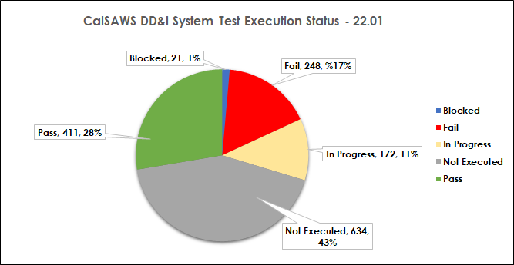
Note: Test script counts are subject to change as test scripts are added or removed throughout the execution phase
- The above chart is cumulative of CalSAWS Modifications & Enhancements (M&E) and CalSAWS Design, Development, and Implementation (DD&I) System Change Requests (SCRs) System Test Execution

Table 4.3.1-2 – CalSAWS GA/GR Correspondence System Test System Change Request (SCR) Test Status

Pass Rate Target as of December 12, 2021 | 29%
Pass Rate Actual as of December 12, 2021 | 15%
System Test Complete Date: January 19, 2022

Figure 4.3.1-2 – CalSAWS GA/GR Correspondence System Change Request (SCR) Test Status

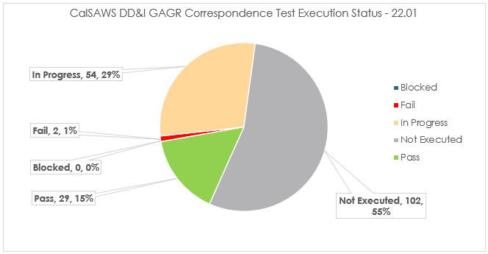

- Gainwell Technologies GAGR Correspondence Service
  - 187 scenarios have been identified, 45% of scripts have been executed or are in progress

Automated Regression Test (ART) Coverage

Table 4.3.2-1 – CalSAWS Automated Regression Test (ART) Coverage
Production Transactions |  |  |  | ART Coverage by Production Volume
Tier | Distinct | Volume | % Vol. | Distinct | % Coverage
1 | 15 | 79,792,847 | 45.01% | 14 | 97.93%
2 | 105 | 61,952,754 | 34.95% | 101 | 96.12%
3 | 121 | 17,791,644 | 10.04% | 108 | 91.51%
4 | 455 | 14,899,223 | 8.40% | 247 | 62.56%
5 | 2686 | 2,845,279 | 1.60% | 404 | 27.15%

- Note: Transaction volume and coverage metrics are based on CalSAWS monthly production performance data as of November 30, 2021, and Automated Regression Test (ART) coverage data as of September 30, 2021. Each tier is distinct from prior tier(s). For example, tier 2 includes all transactions that make up the top 80% of production volume except for the fifteen tier 1 transactions. Production statistics are updated each month, and coverage statistics are updated with each major release as new automated regression scripts are developed. To date, there are 538 end-to-end Automated Regression Test (ART) scripts
- Note: Production transaction volumes and patterns were expected to fluctuate as the former C-IV Counties transitioned into CalSAWS and stabilize in November. Production usage data from November is reflected above. Automated Regression Test (ART) coverage data is not available for October and November

Training Materials Update
- Online Help System Change Requests (SCRs) for 22.01 are in System Test
- Continue 22.03 Impact Analysis for Online Help (OLH) updates
- Started 21.11 Impact Analysis for Web Based Training (WBT) updates
- Delivered Major Upcoming Changes email for the 21.11 Release on December 2, 2021
- Hosted Weekly CalSAWS Training team meetings on December 7, 2021
- Hosted discussion on Instructor Led Training (ILT) materials update on December 2, 2021
- Introduced and hosted a meeting with the Training Consortium and Meridian for turnover and training scheduled for January 2022
- Web Based Training (WBT) System Change Requests (SCRs) for 21.01-21.07 currently in process
- Training Environments
  - Continued to work cross-team to troubleshoot CalSAWS Training Staging and Training Production environment tickets
- Learning Management System (LMS)
  - Continued to work cross-team to troubleshoot CalSAWS Learning Management (LMS) Tickets
  - Continued training for Learning Management System (LMS) support to the Consortium Training team

Figure 4.4-1 – Weekly Training SCR Status Report
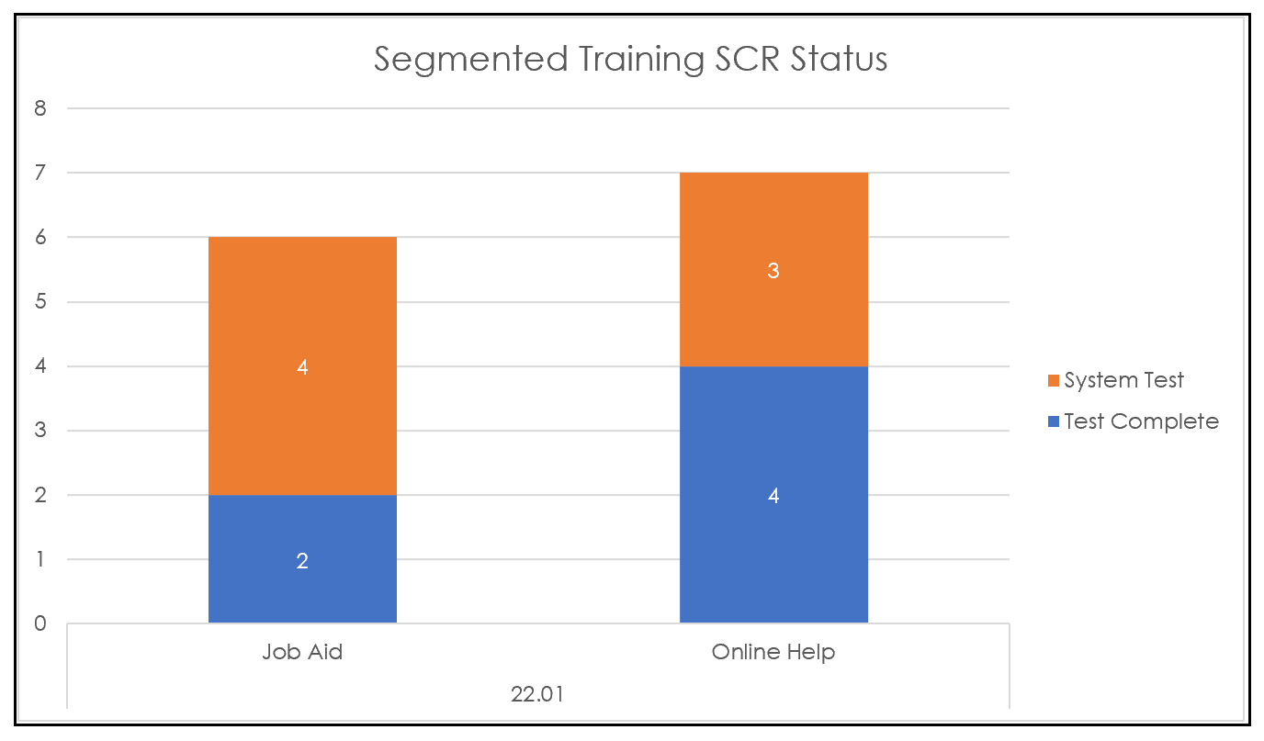

Table 4.4-2 – Upcoming Training Activities
Training Activity | Date
Training Committee Meeting | January 5, 2022
Refresh Schedule for Training Production Environment | January 7, 2022

Deviation from Plan/Adjustments

- None for the reporting period

Regional Updates

- None for the reporting period

Appendices

Appendix A – M&E Requests and SCR Status
Appendix B – County Purchases Status Report
Appendix C – CalSAWS System IVR Report
Appendix D – COVID SCRs

